#Logging in AWS

#Create AMI Rule

#Create AMI Policy for the Rule (or Create AMI policy and attach to AMI Rule

#Create S3 Bucket

#Create EC2 Instance while selecting AMI Rule or create EC2 Instance and then Add AMI rule after creating EC2 Instance

#Install AWS in EC2

#Create Shell Script inside EC2

#Add the script in the cron for schedule run

<https://aws.amazon.com/>

1. Open the AWS URL: <https://aws.amazon.com/>

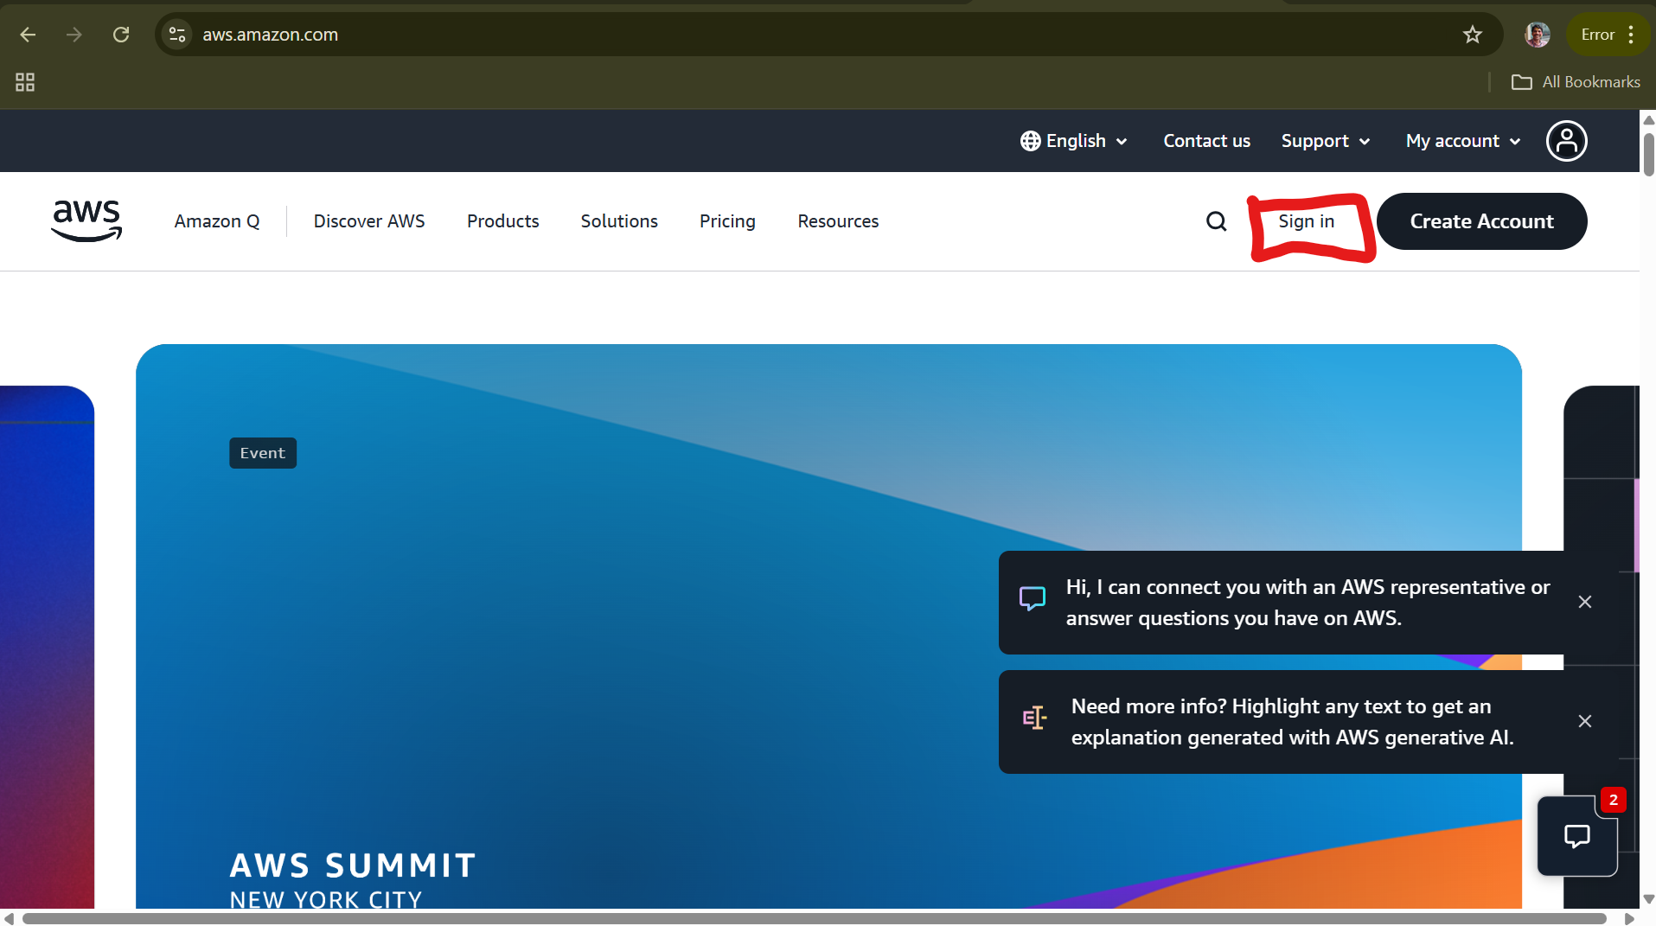

1. Click on Sign in

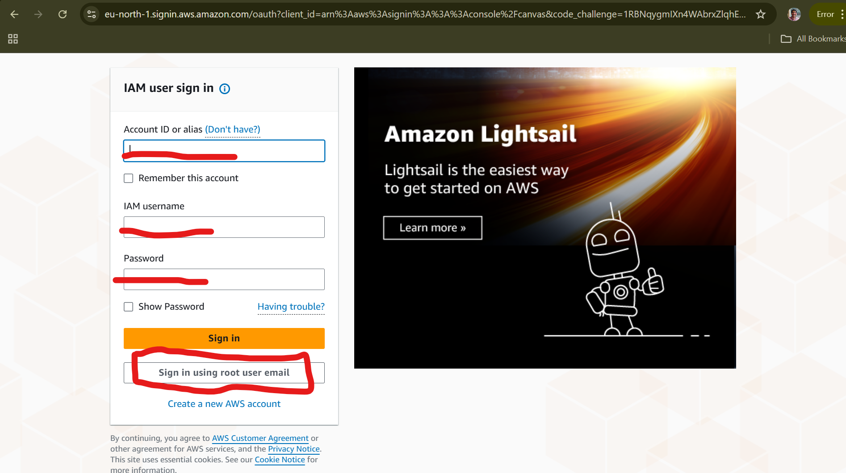

1. Either Sign in with IAM User or Sign in using root user email. For this instance, I am logging with root user by clicking on **sign in using root user email and** Click on **Next.**

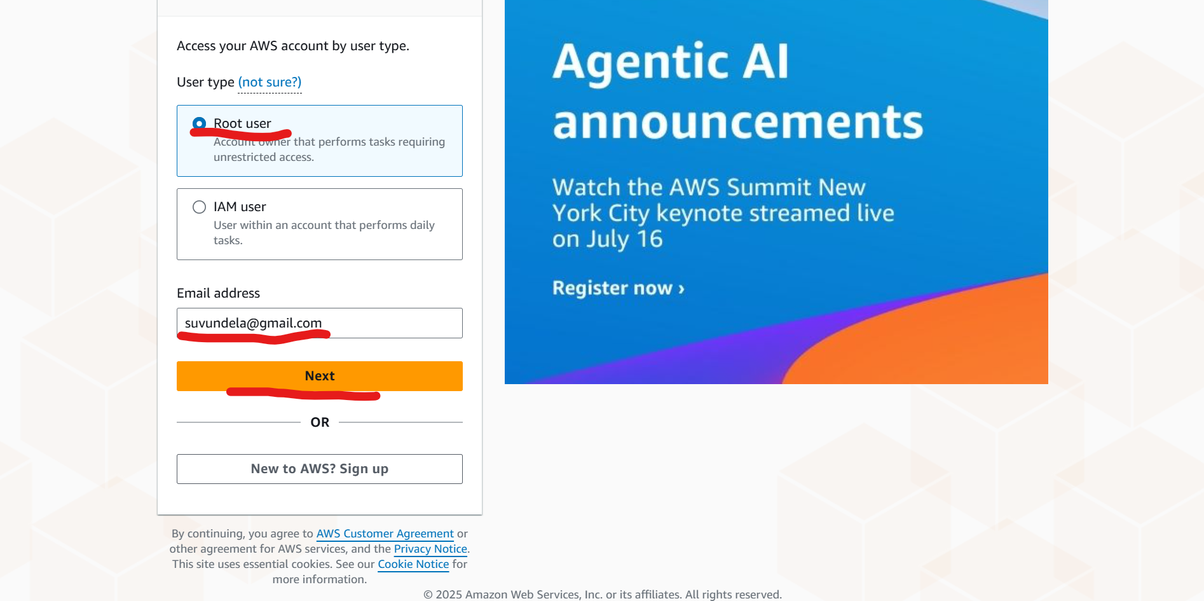

1. Enter the password and click on Sign.

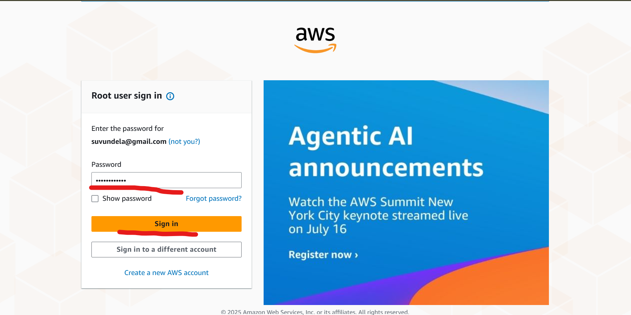

1. You will be logging into Console Home as shown below screenshot.

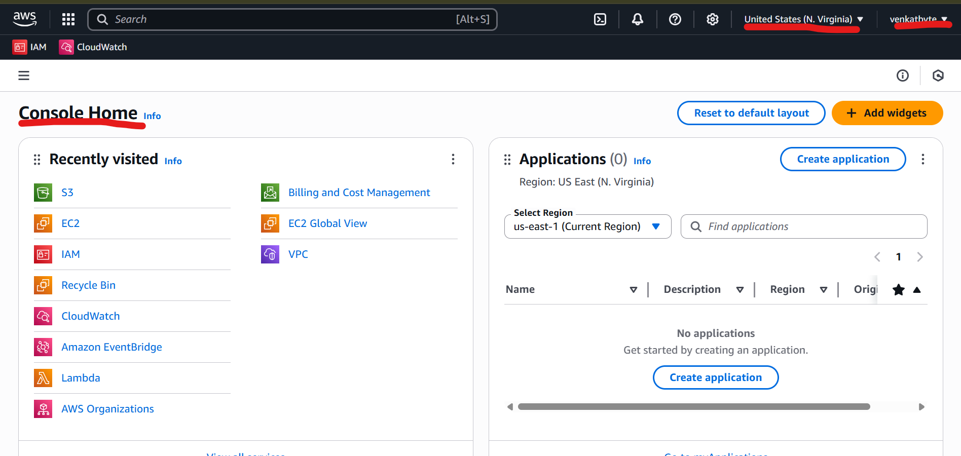

1. Next, we are going to create IAM rule for the EC2 to take AMI Images and Upload it to S3 Bucket.

In order to create IAM role, enter the IAM in the Search.

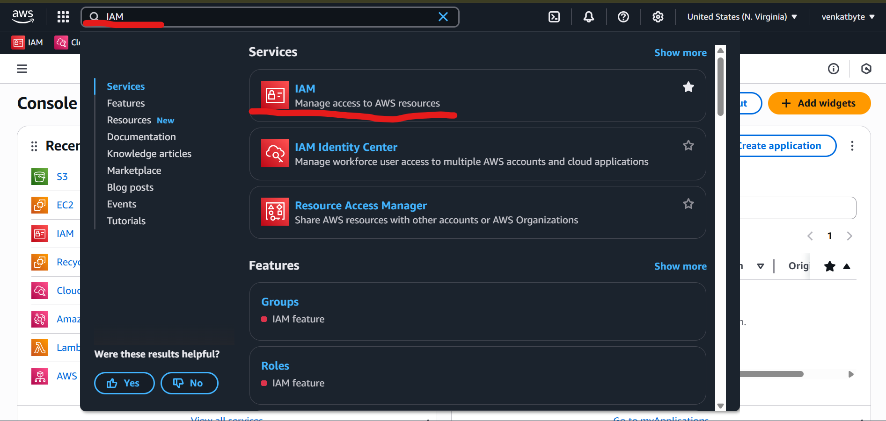

1. Click on IAM in the Services. You will be redirected to IAM > Dashboard. Then Click on Roles.

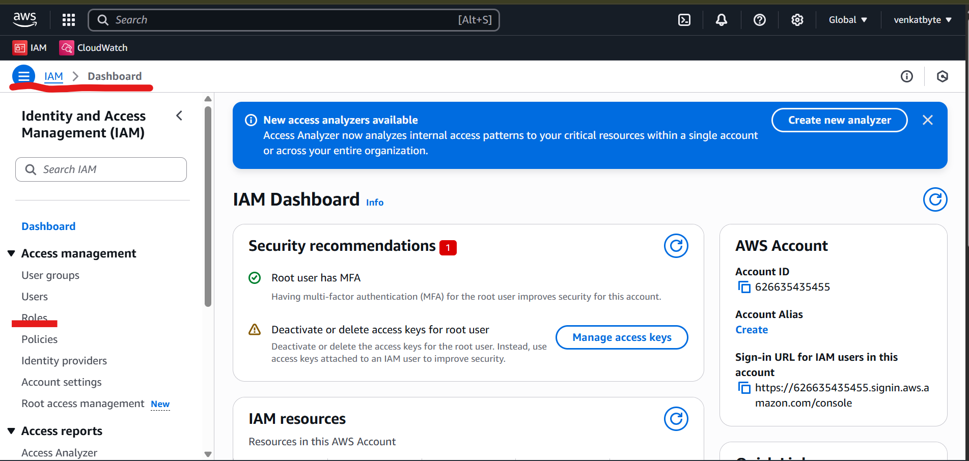

1. You will be redirected to Roles IAM > Roles. Click on Create role

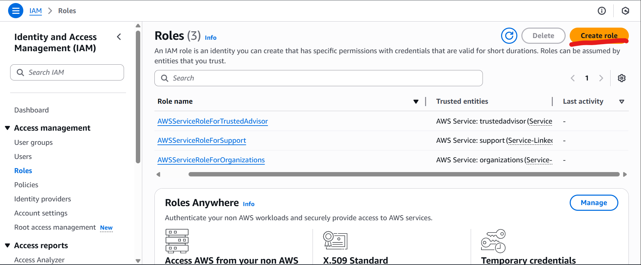

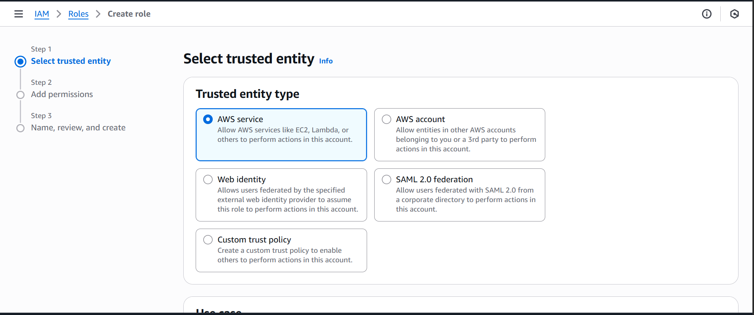

1. Select trusted entity as AWS service and Choose a service as EC2 from Use Case drop down and click Next

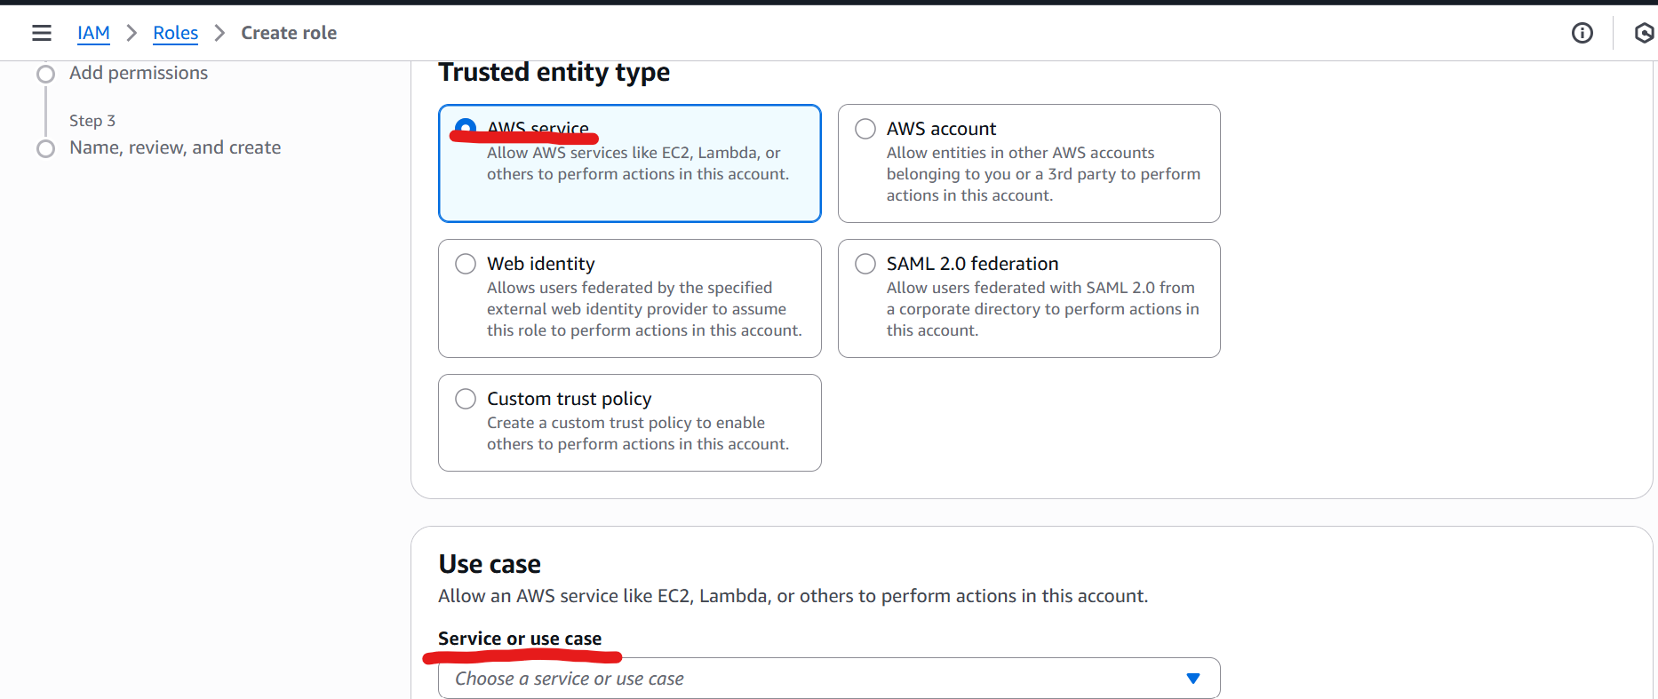

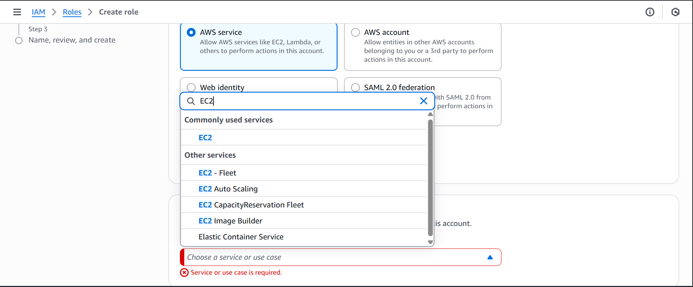

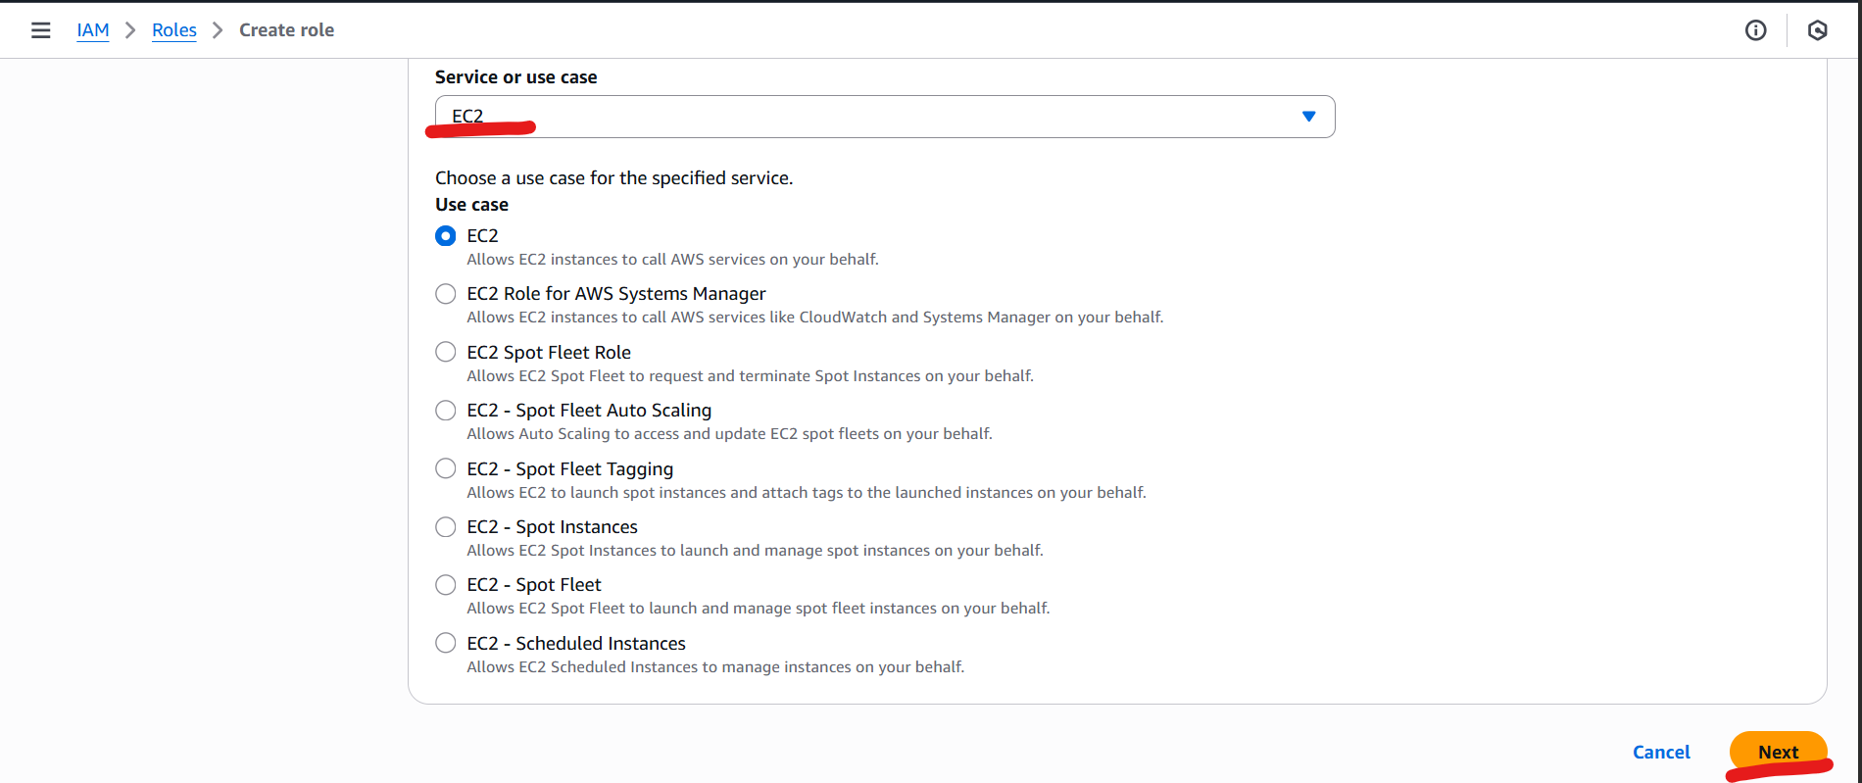

1. Next Step is Permission Policies (Do not select any policy), just drag down to bottom of the screen and click Next.

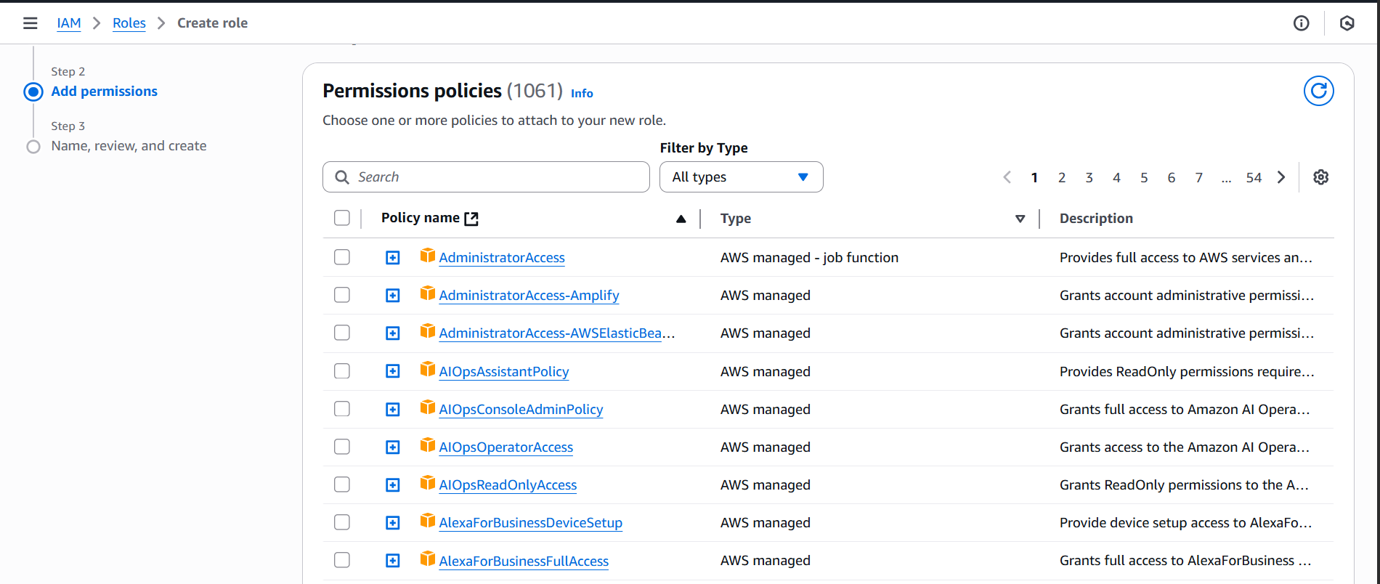

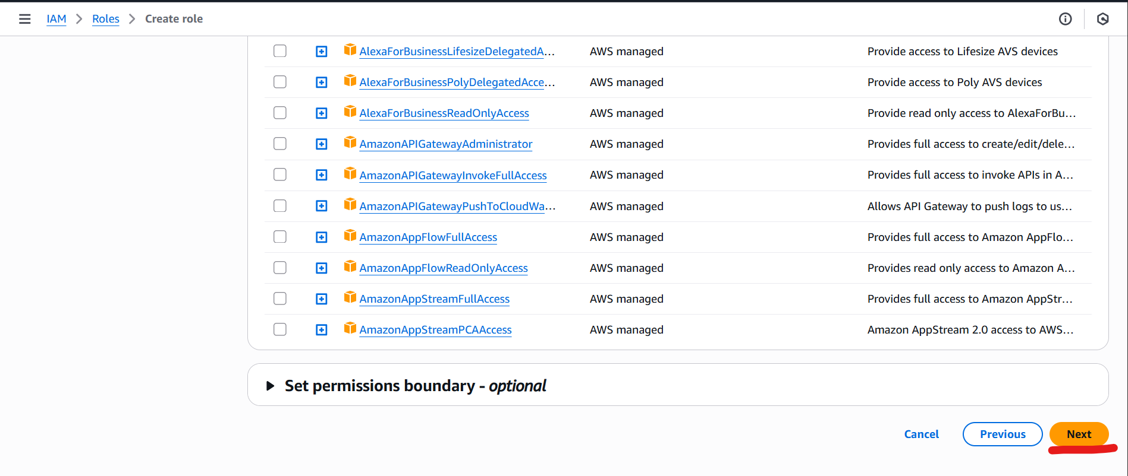

1. Provide the rule name and scroll down to last and select create role.

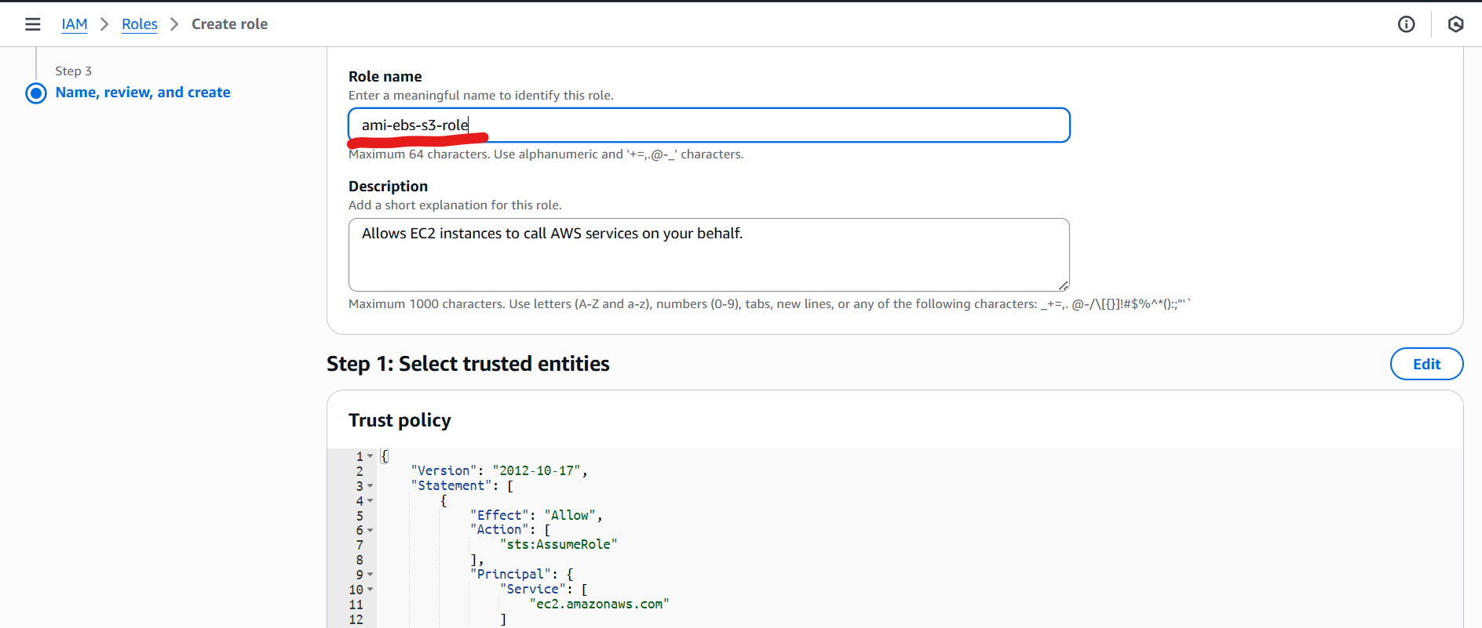  
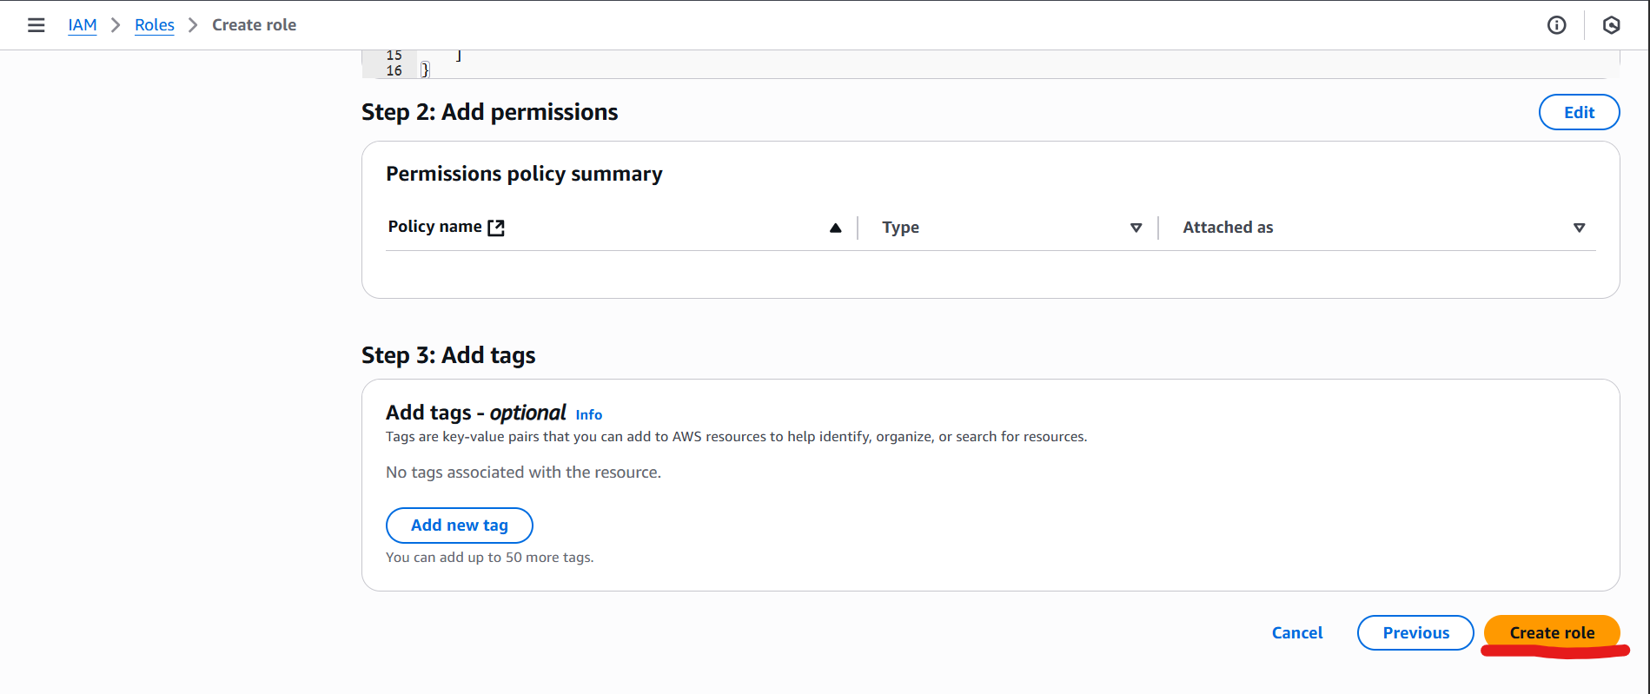

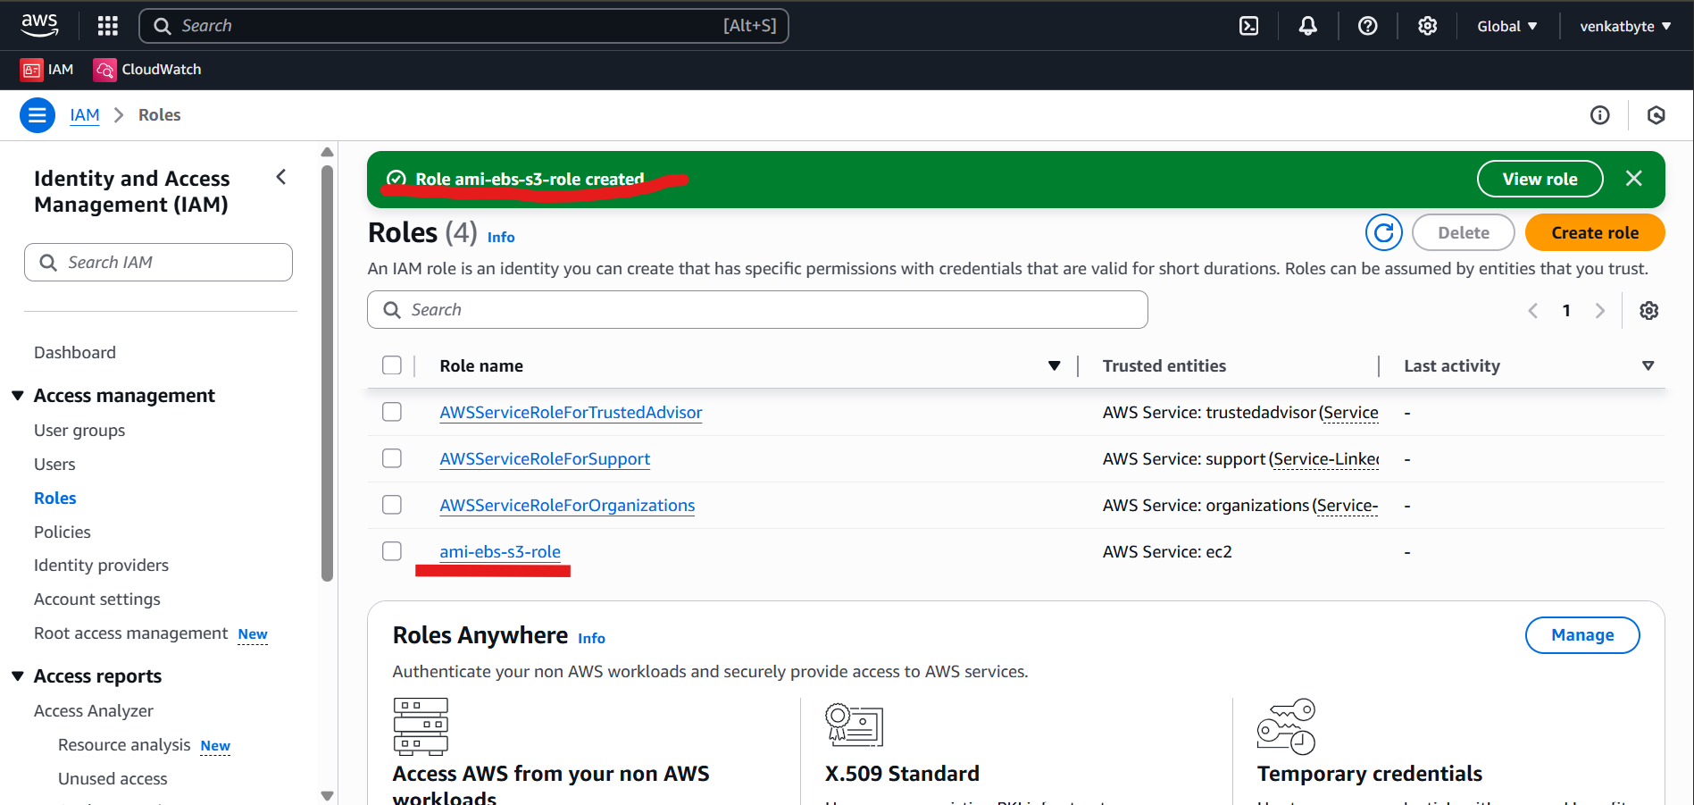

1. Select the newly created role ami-ebs-s3-role to define the custom policy (permissions) to the role.

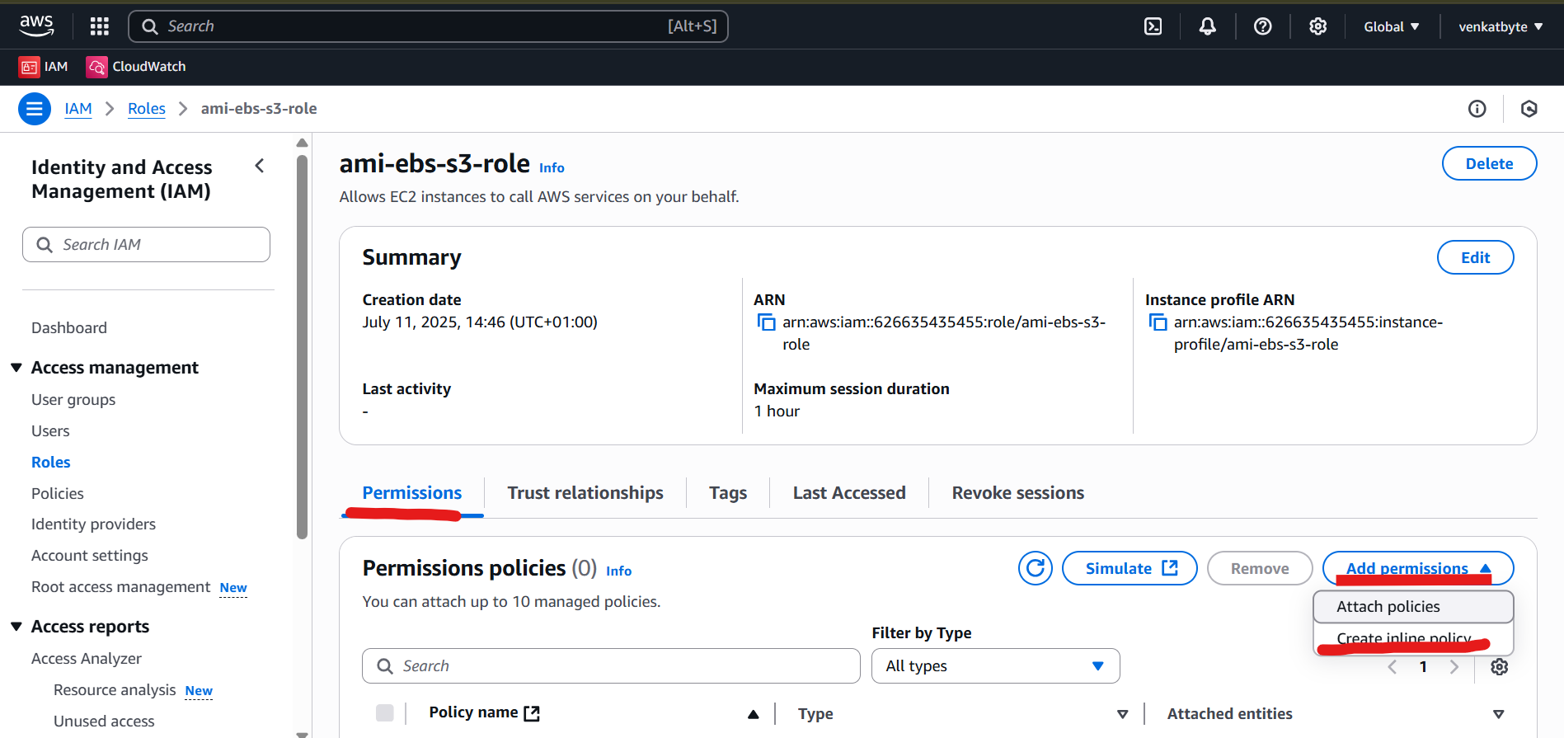

1. Select Permissions and Click Create inline policy from Drop down of Add permission

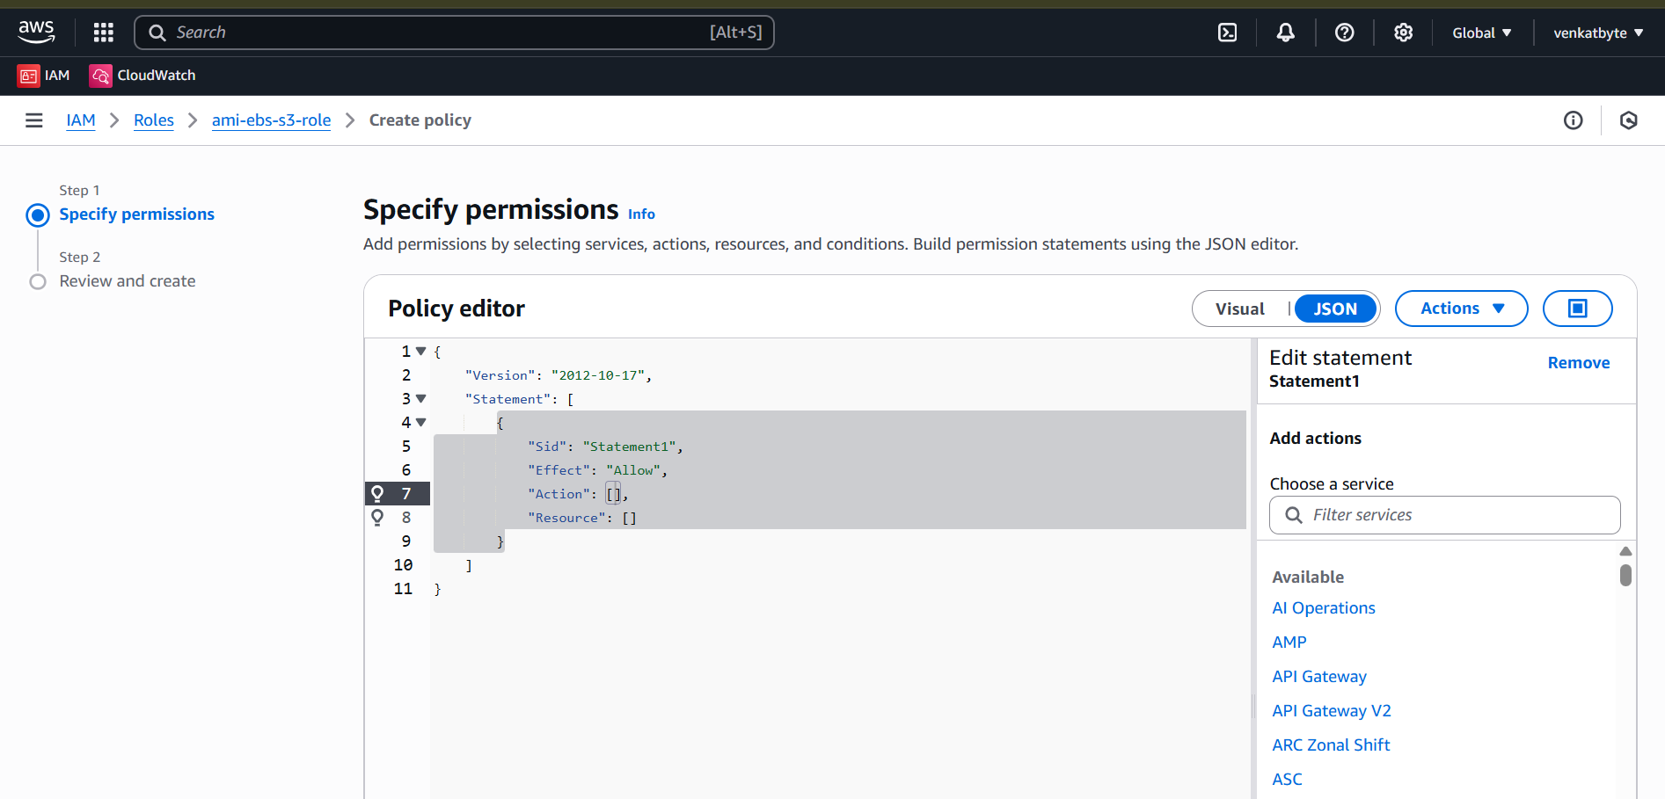

1. Select JSON Policy editor in the Specify permissions and copy paste below json custom policy from VENKATBYTE GitHub. And scroll last and click Next.

<https://raw.githubusercontent.com/venkatbyte/aws-ami-store-s3/refs/heads/main/iam-rule-policy-for-ec2.json>

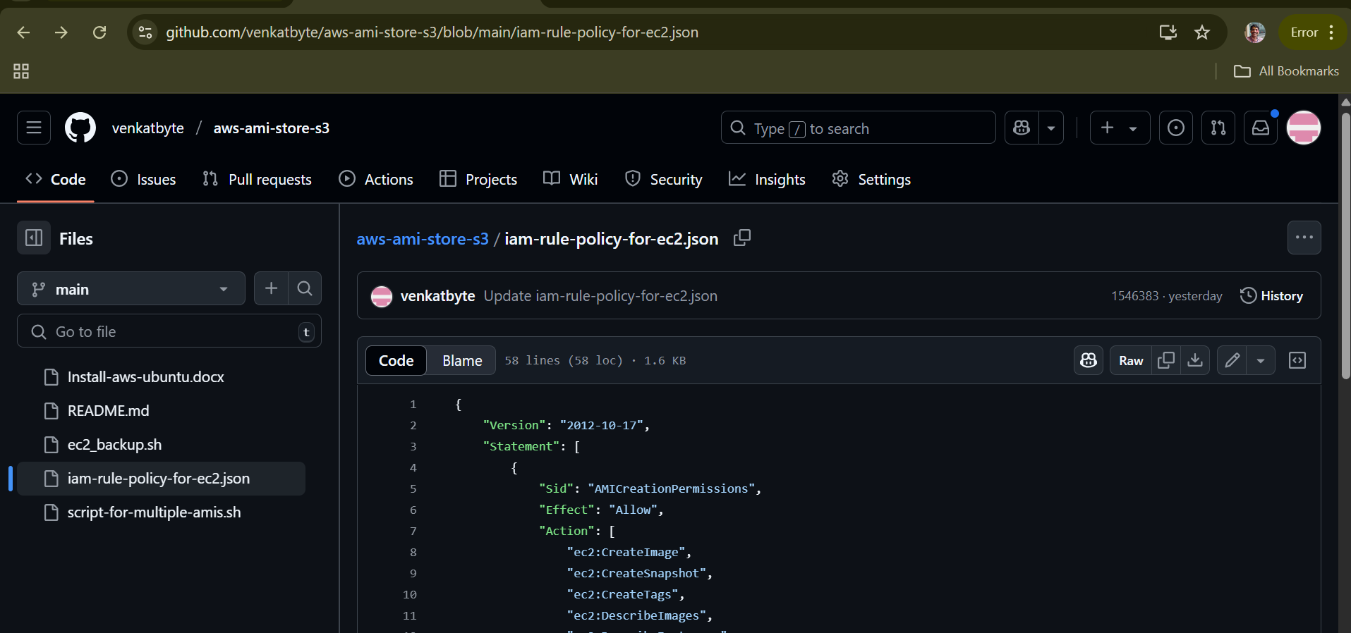

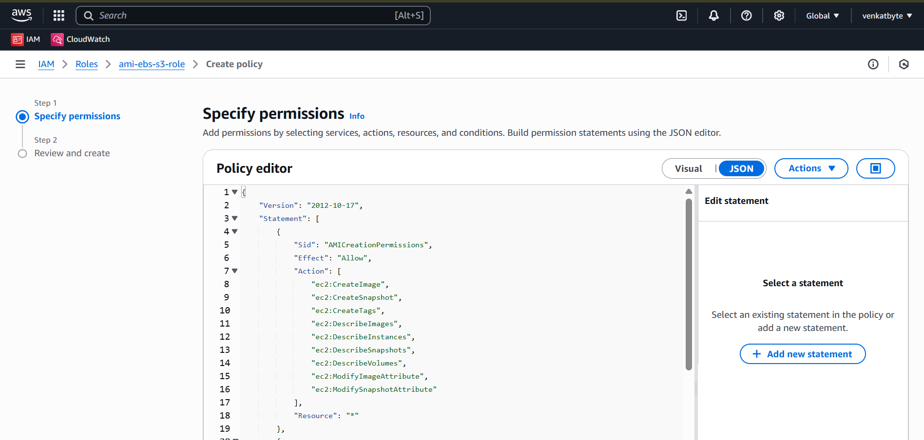

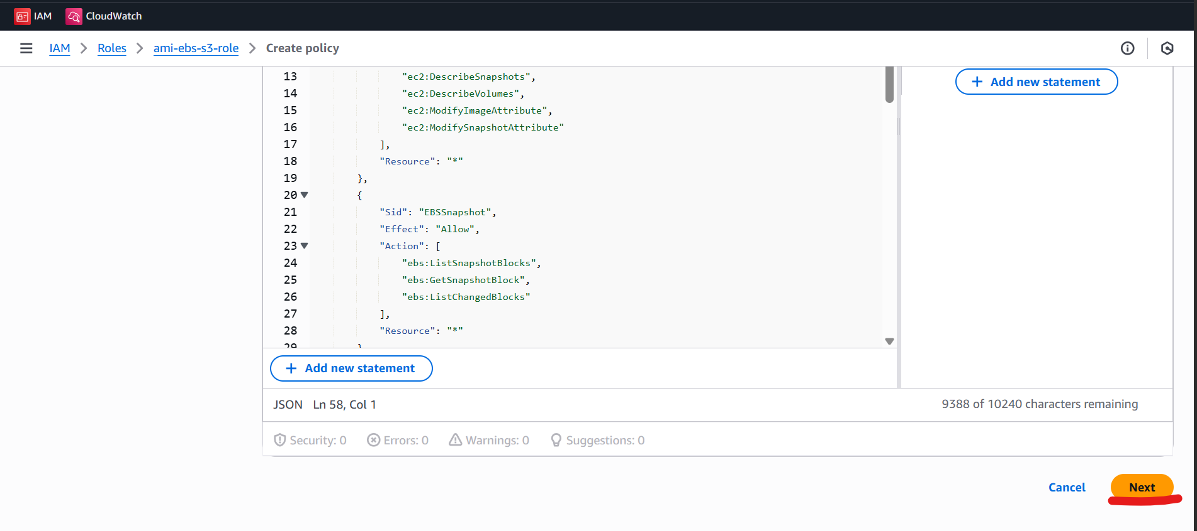

1. Provide policy name and click create policy.

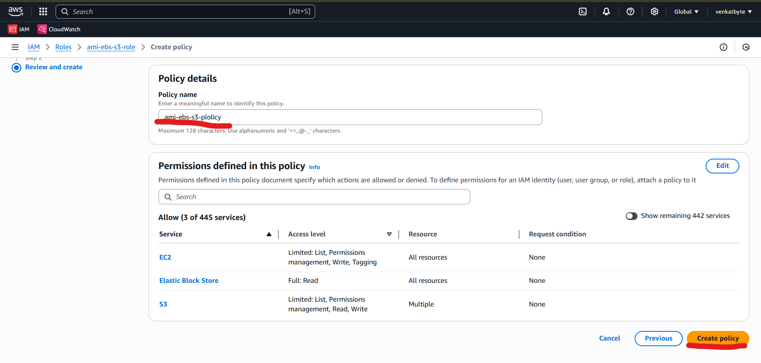

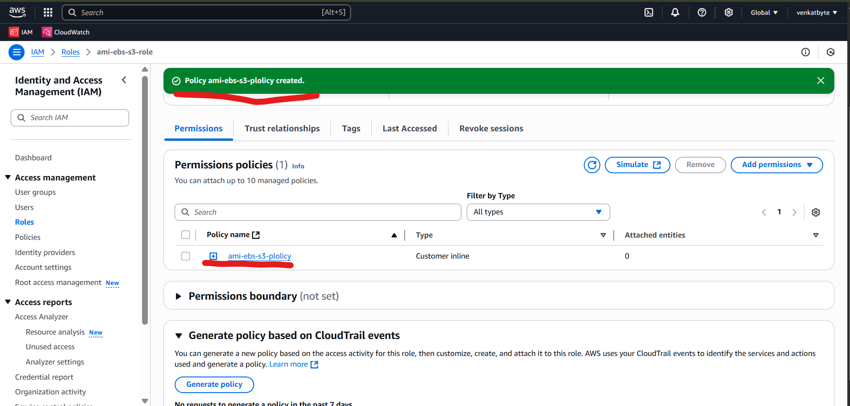

1. Next step is to create S3 bucket.

Search for S3 in main search box next to AWS and select S3 from Serices.

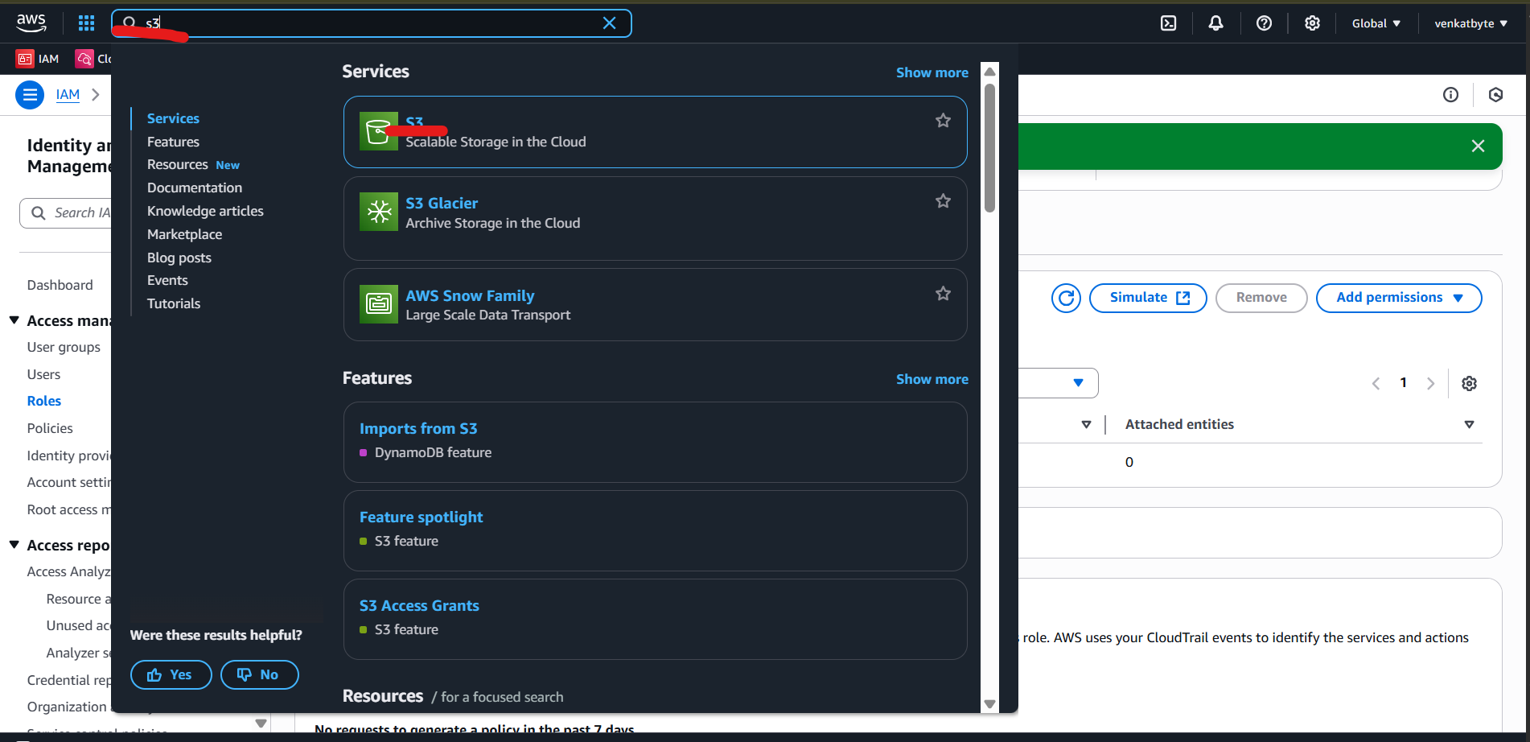

1. Click on Create bucket.

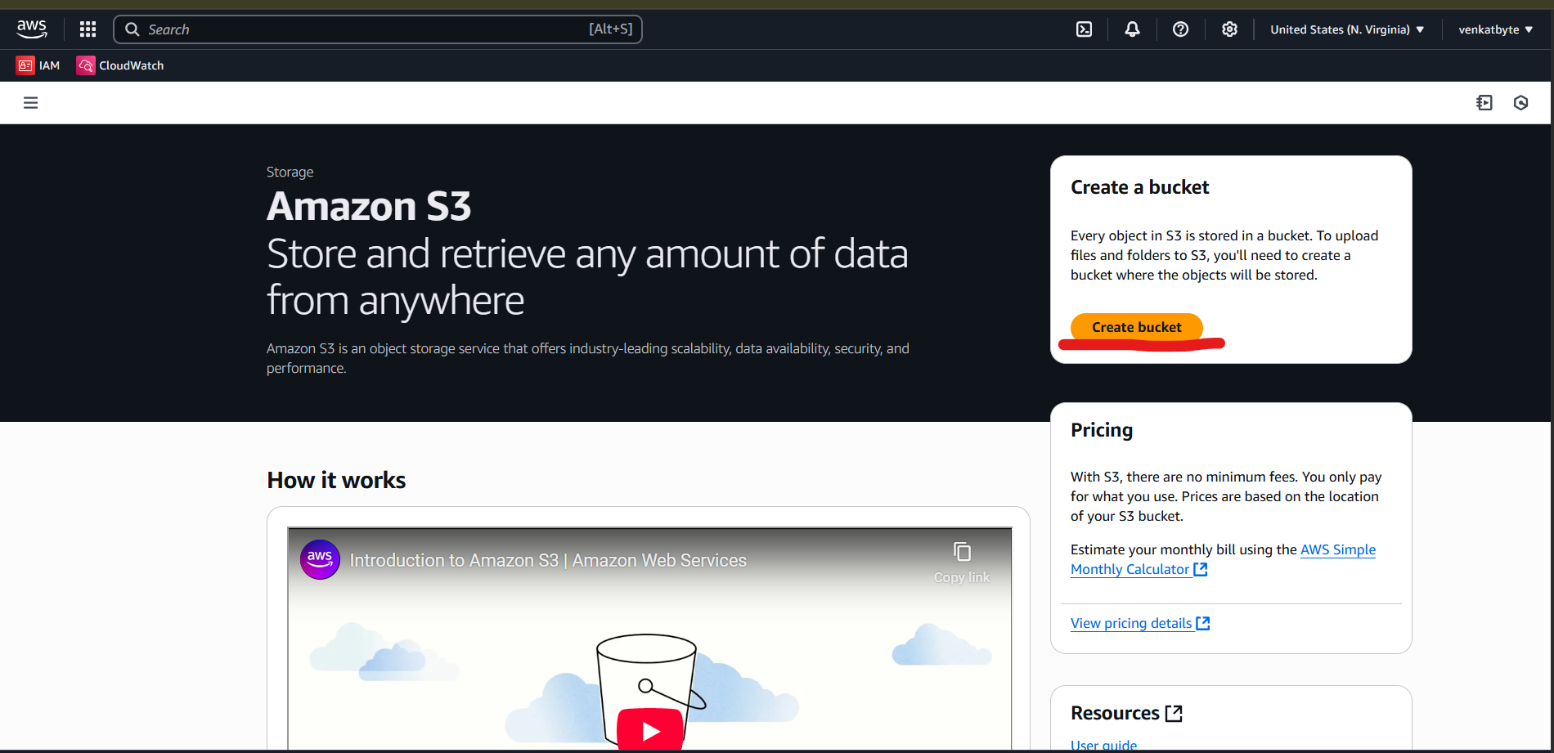

1. Select bucket type is General purpose and bucket name is venkatbyte, you choose as per your requirement but it should unique in global.

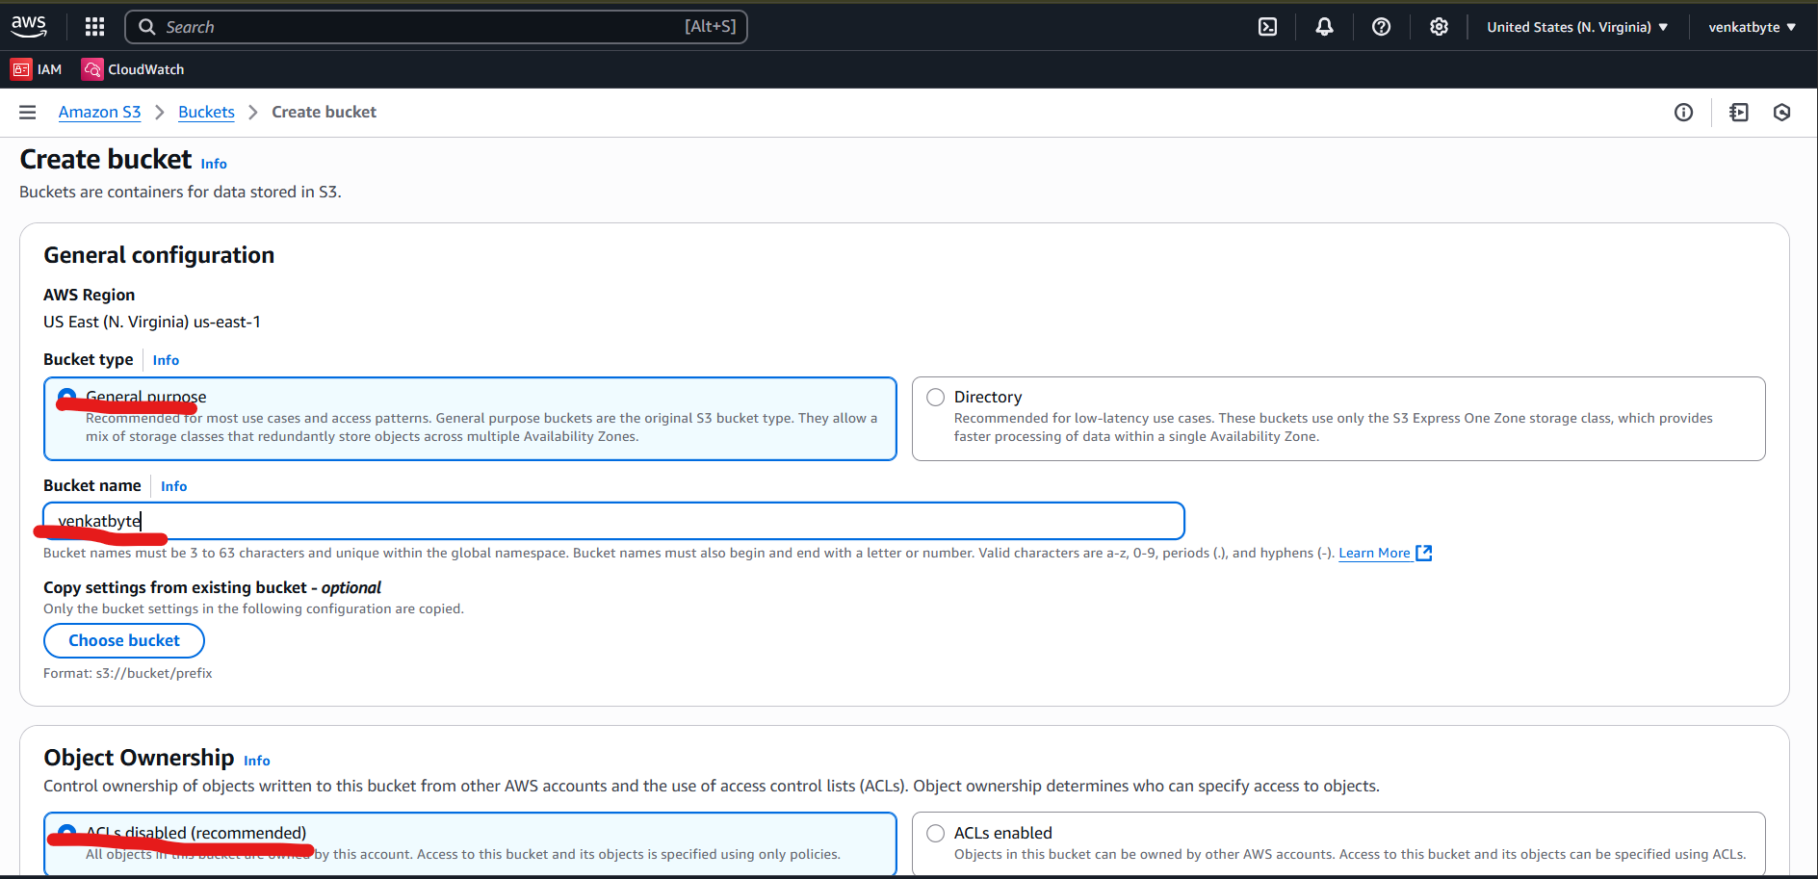

1. Uncheck Block all public access and disable Bucket Versioning, Encryption and Bucket as default options for this case. And click on Create Bucket.

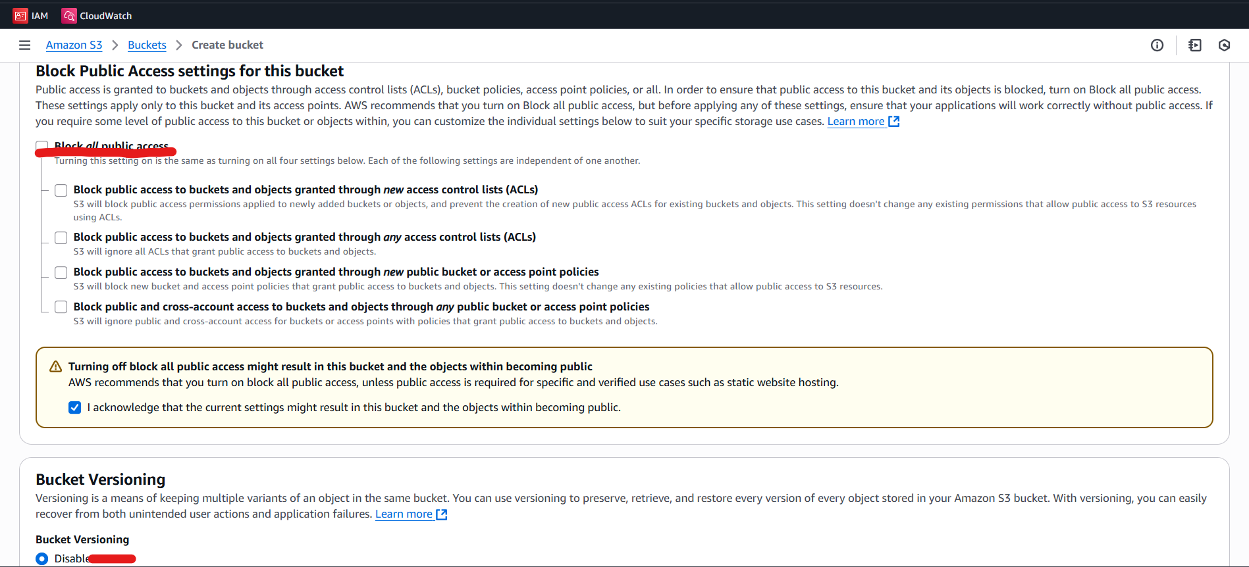

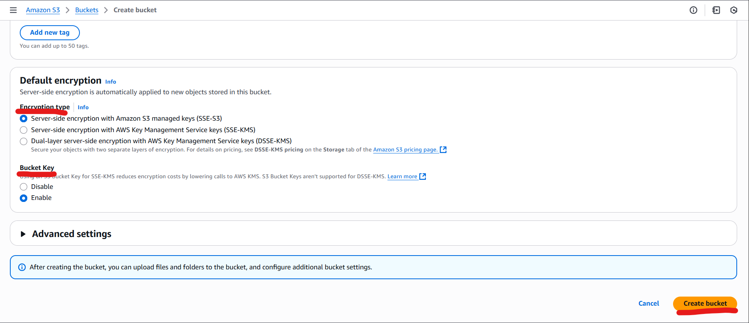

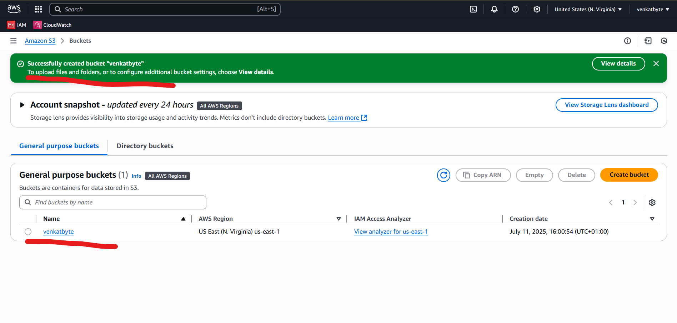

1. Next Step is to create EC2 Instance

Search for EC2 in main search option and choose EC2 in Services

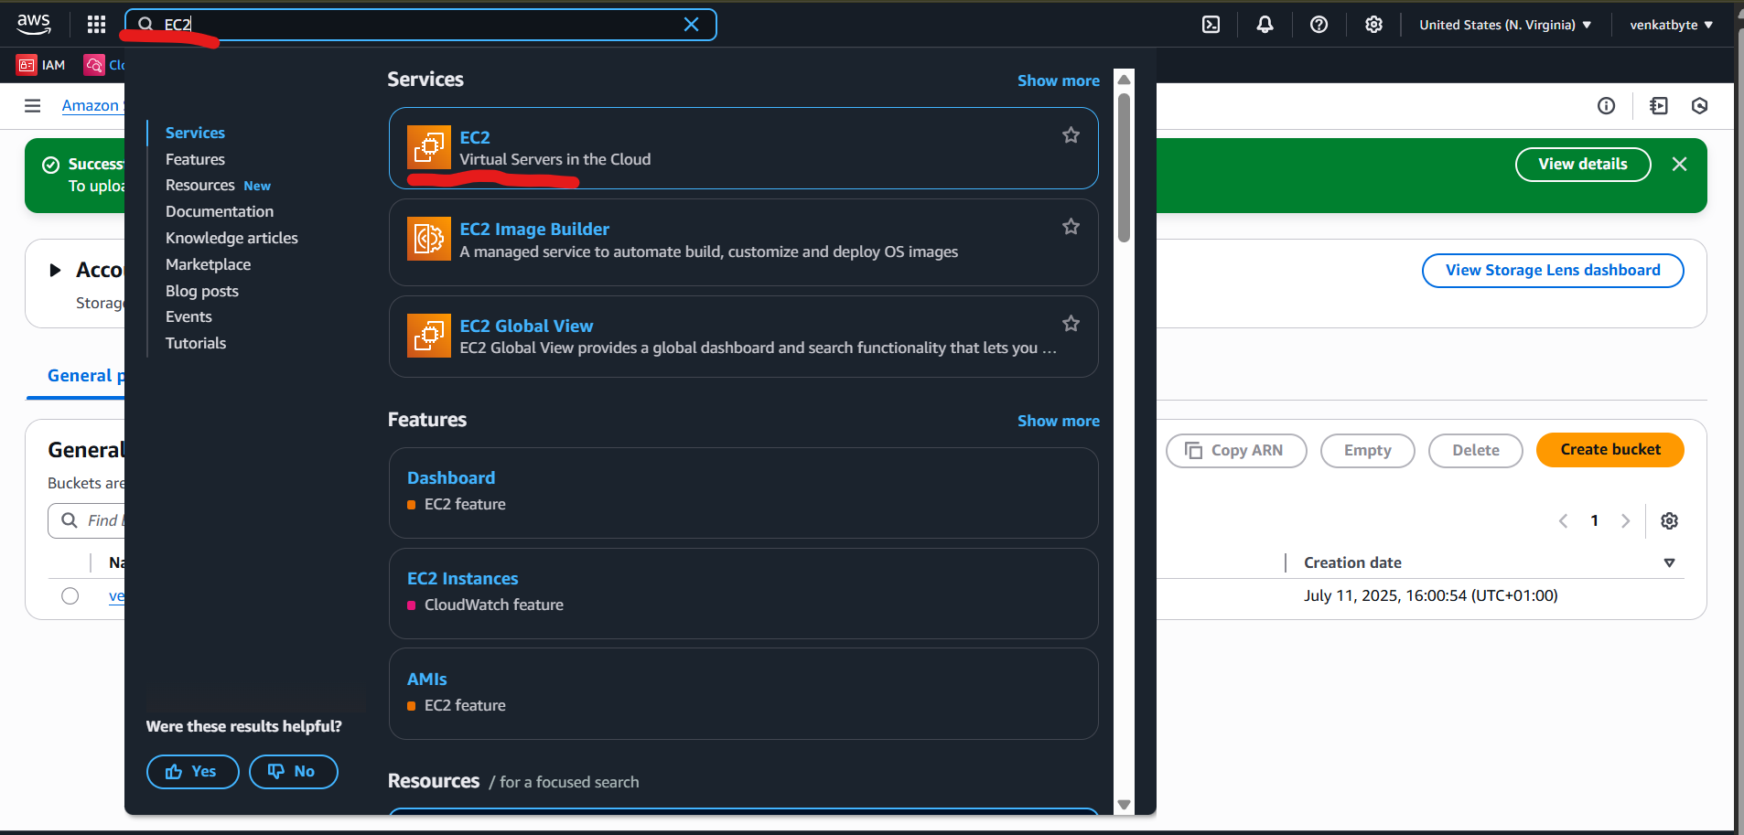

1. Either Select Instances in Instances to see existing EC2 or Launch Instances to create new EC2, for this case ,we are selecting Launch Instances.

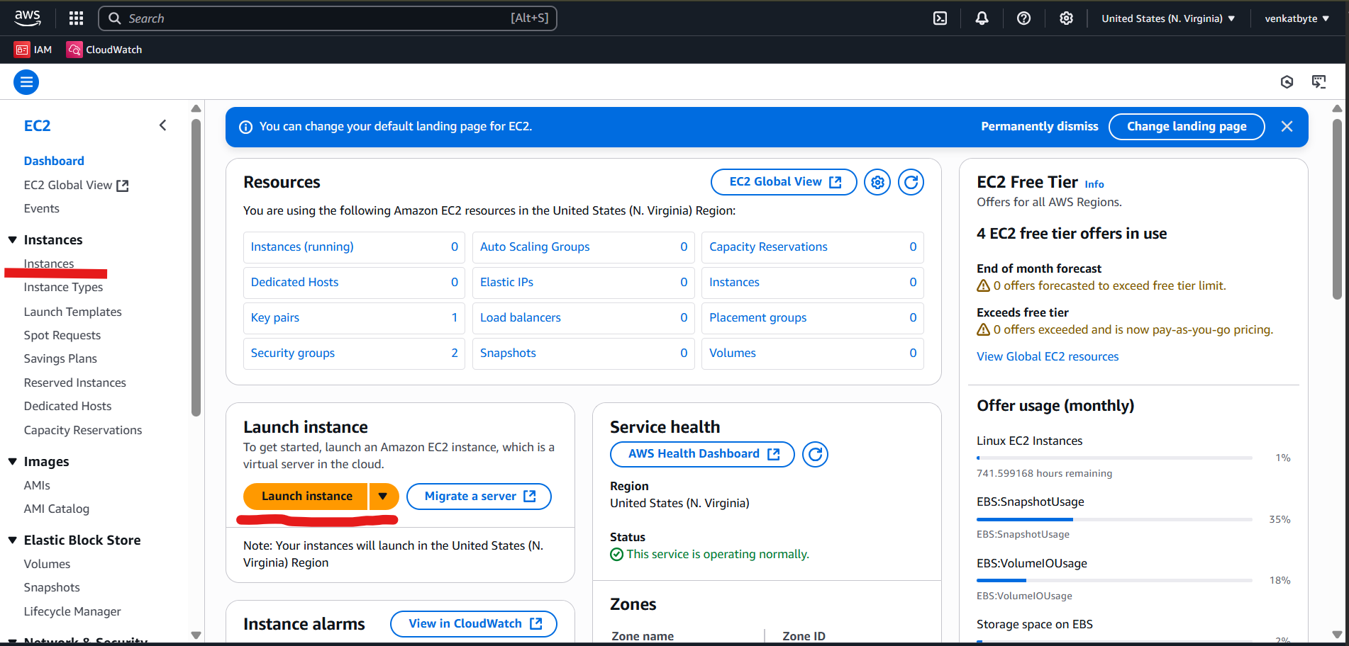

1. Provide Name for new Instance, I am providing vbuslpr01l and Select Ubuntu from Application and OS Images (Amazon Machine Image).

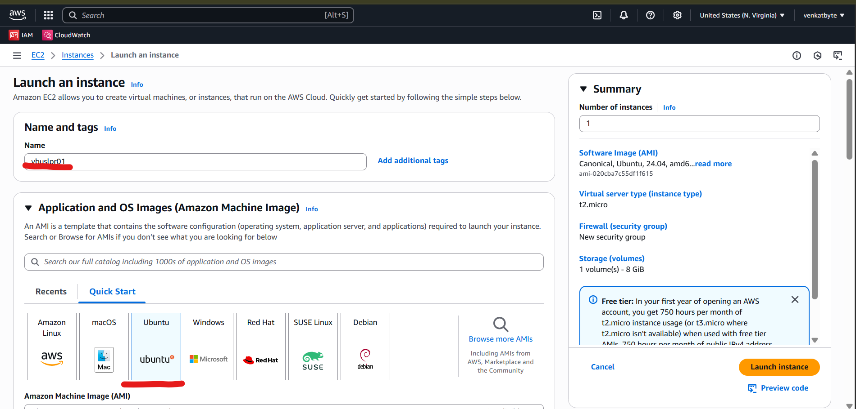

1. Select Ubuntu Server 24.04 from AMI and 64-bit (x86) Architecture and t2.micro Instance type

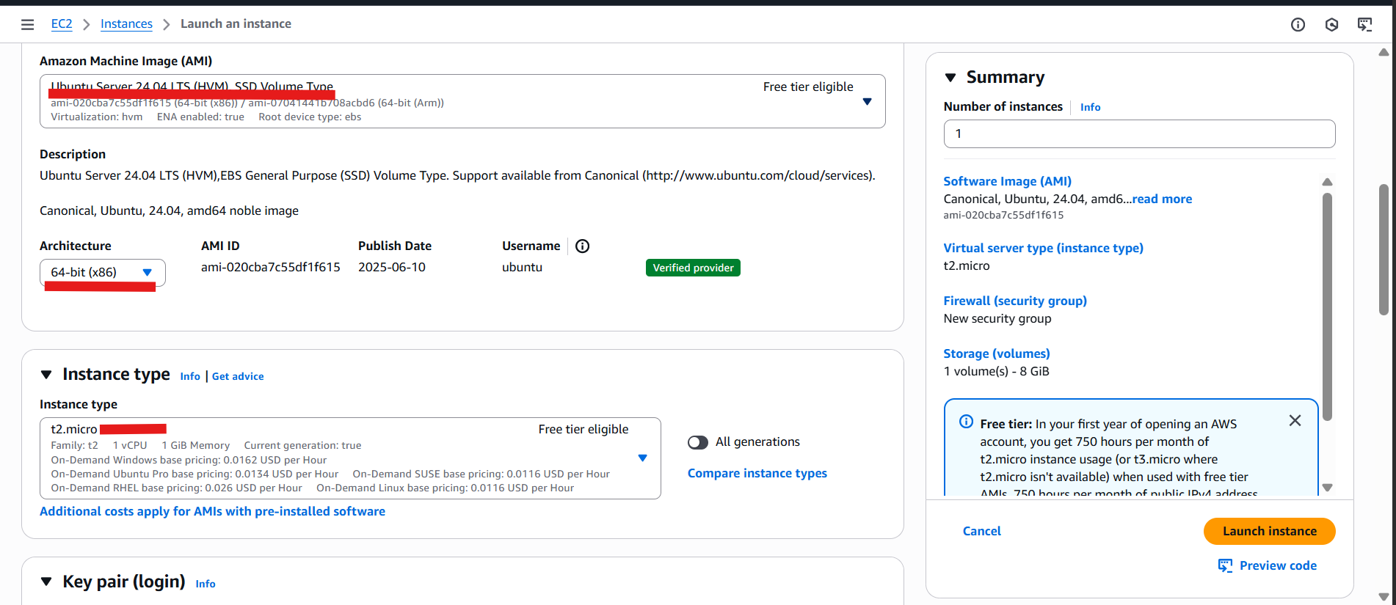

1. Select either existing or new Key pair, VPC, Subnet, Security Groups.

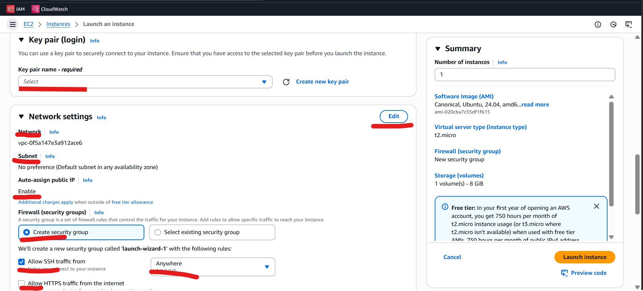

1. In this case, I am using exising Key pair, security group and Default VPC as below.

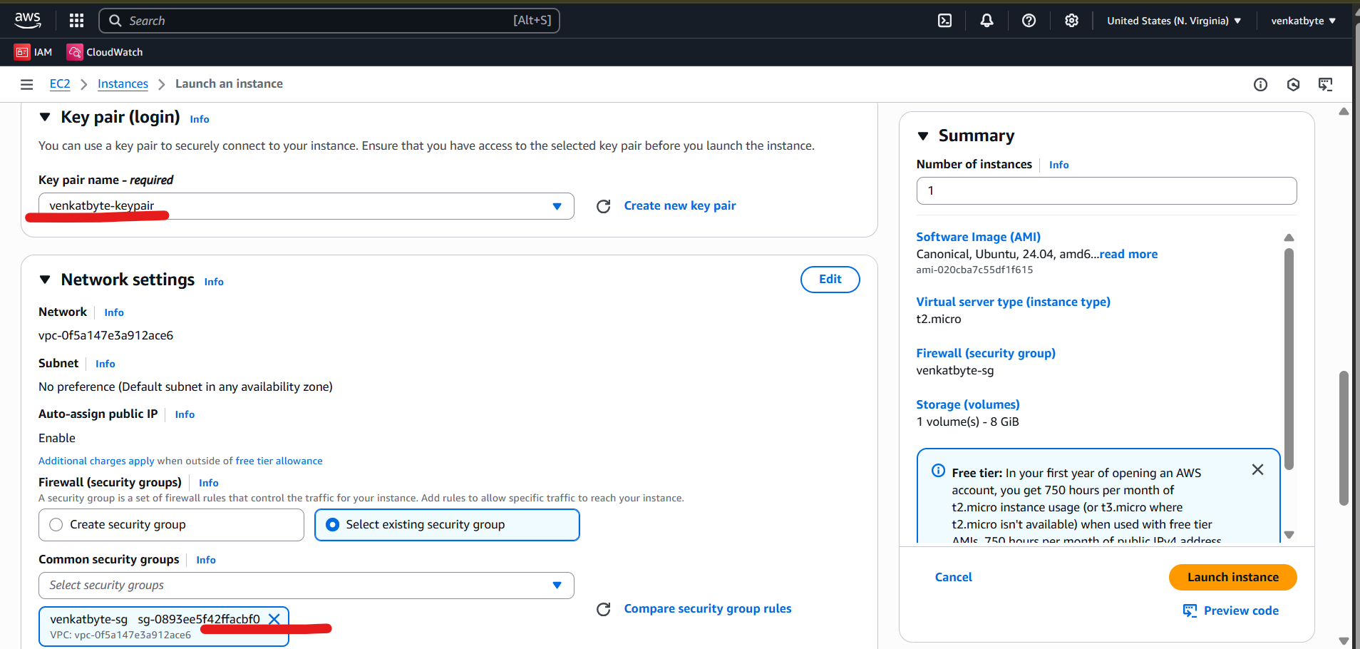

1. Choose Standard storage from Configure Storage and select AMI role ami-ebs-s3-role in IAM Instance profile from Advanced details or leave Advanced details now and you can attach AMI profile once EC2 is created. Then click on Launch Instances.

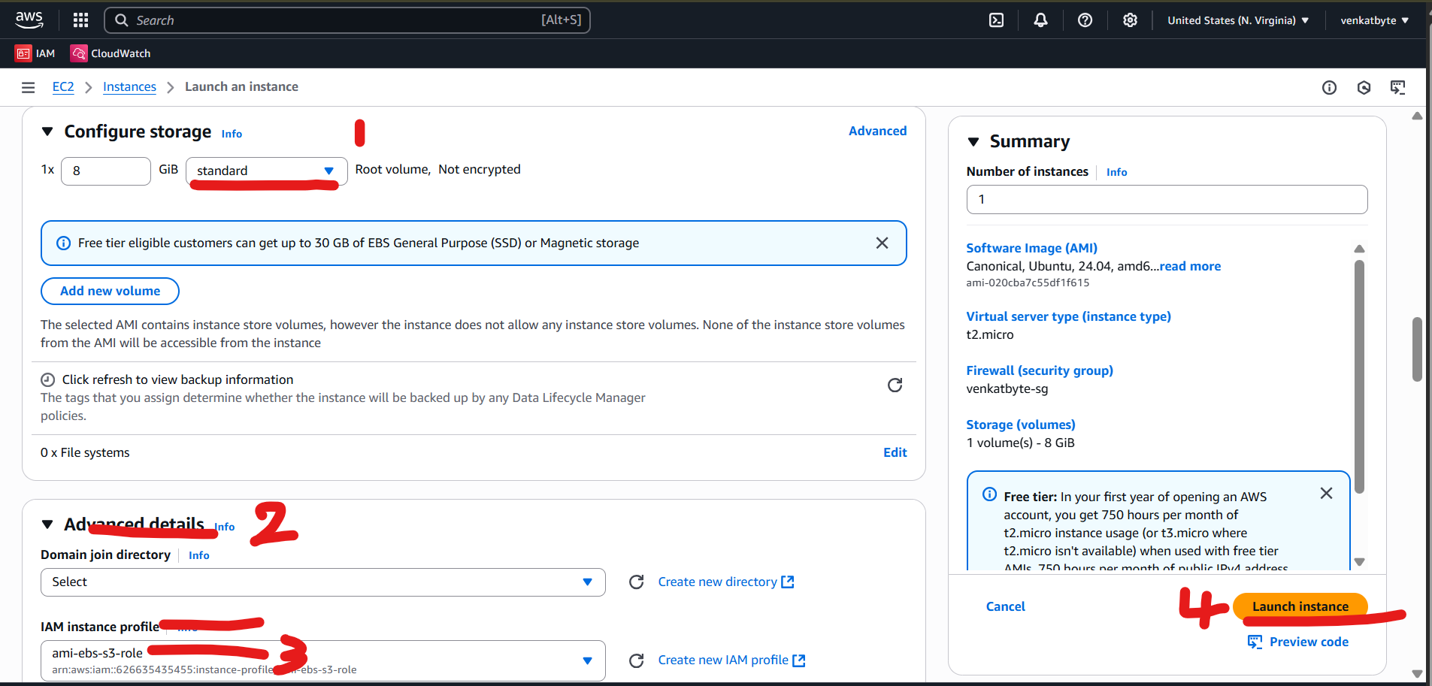

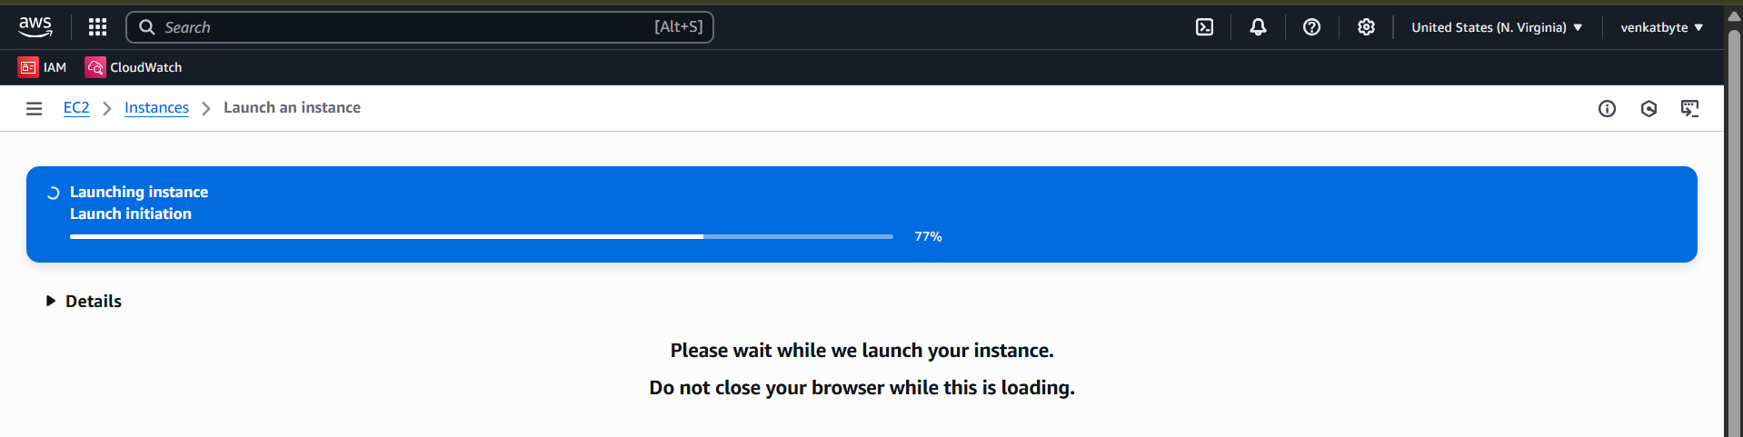

1. Now Instance is created. Now click on Instances or instance ID start with (i-xxxxxxx)

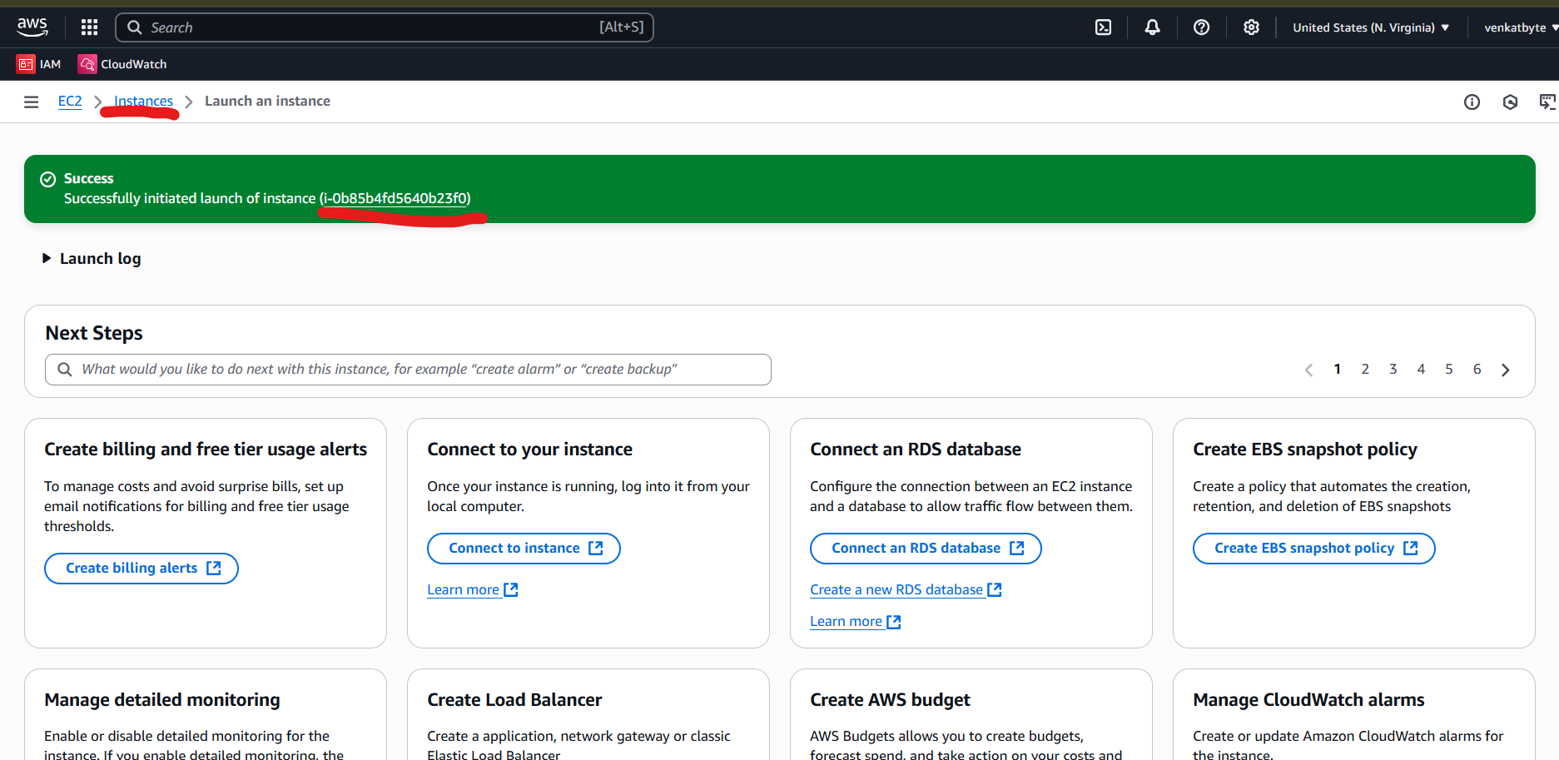

1. Now you can see, the instance is in initializing status. In couple of minutes, it will be 2/2 meaning, all health checks are green and ready to log into server via ssh.

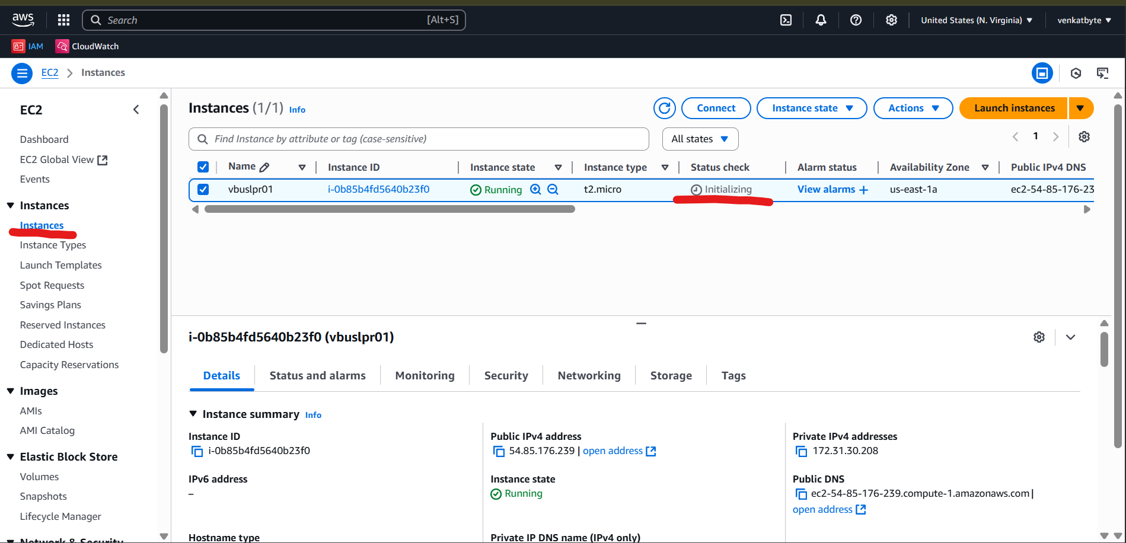

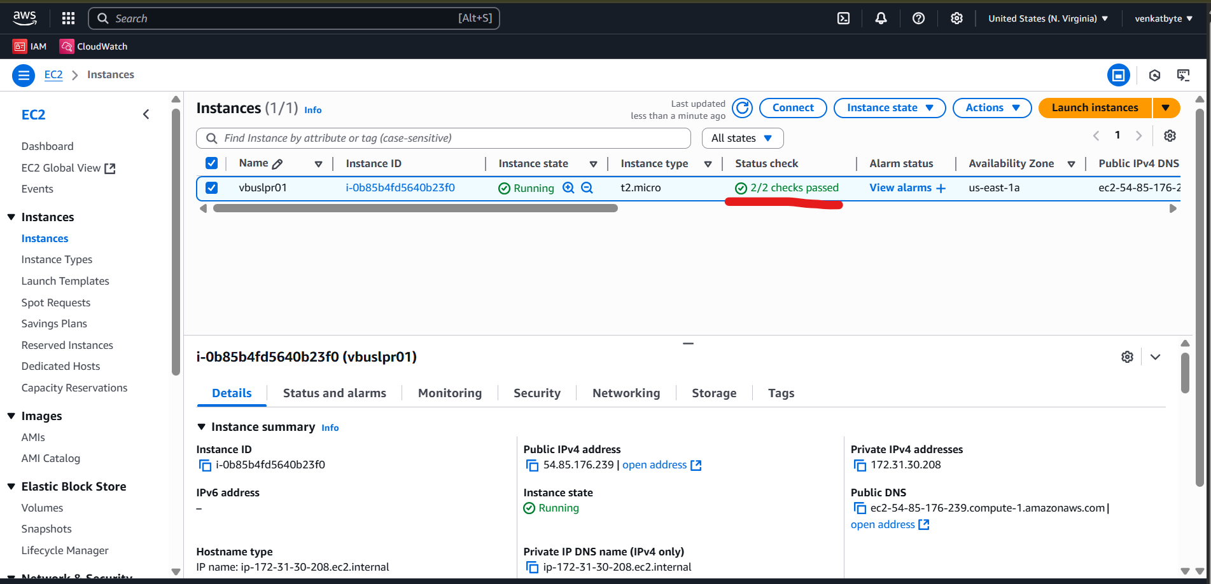

1. As I mentioned earlier in step 26, we can choose AMI role after we create EC2 instance as well.

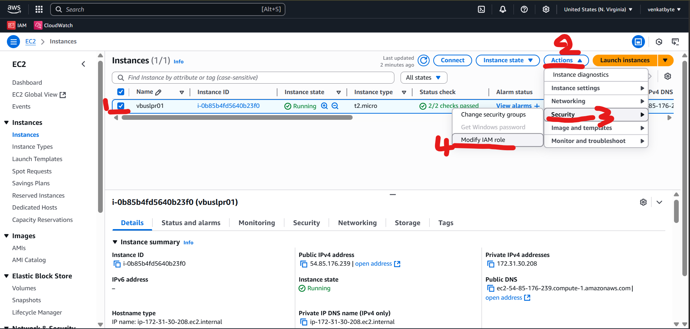

1. Select the check of the Instance, click on Actions > Security > Modify IAM role.

In the drop down of IAM role, select the target IAM role and click on Update IAM role.

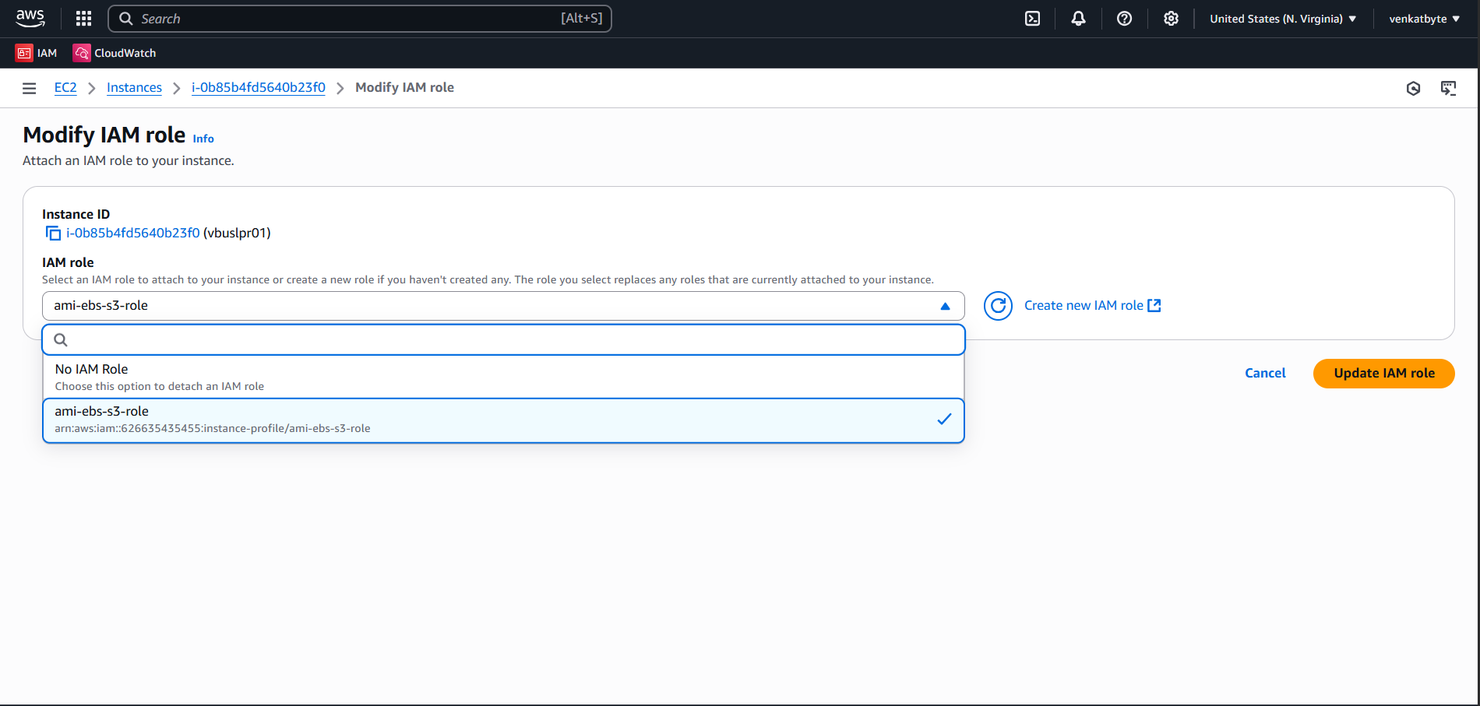

1. Next step is to log in EC2 instance using Key Pair and Install the AWS CLI. In order to log in EC2, you need the public IP of EC2.

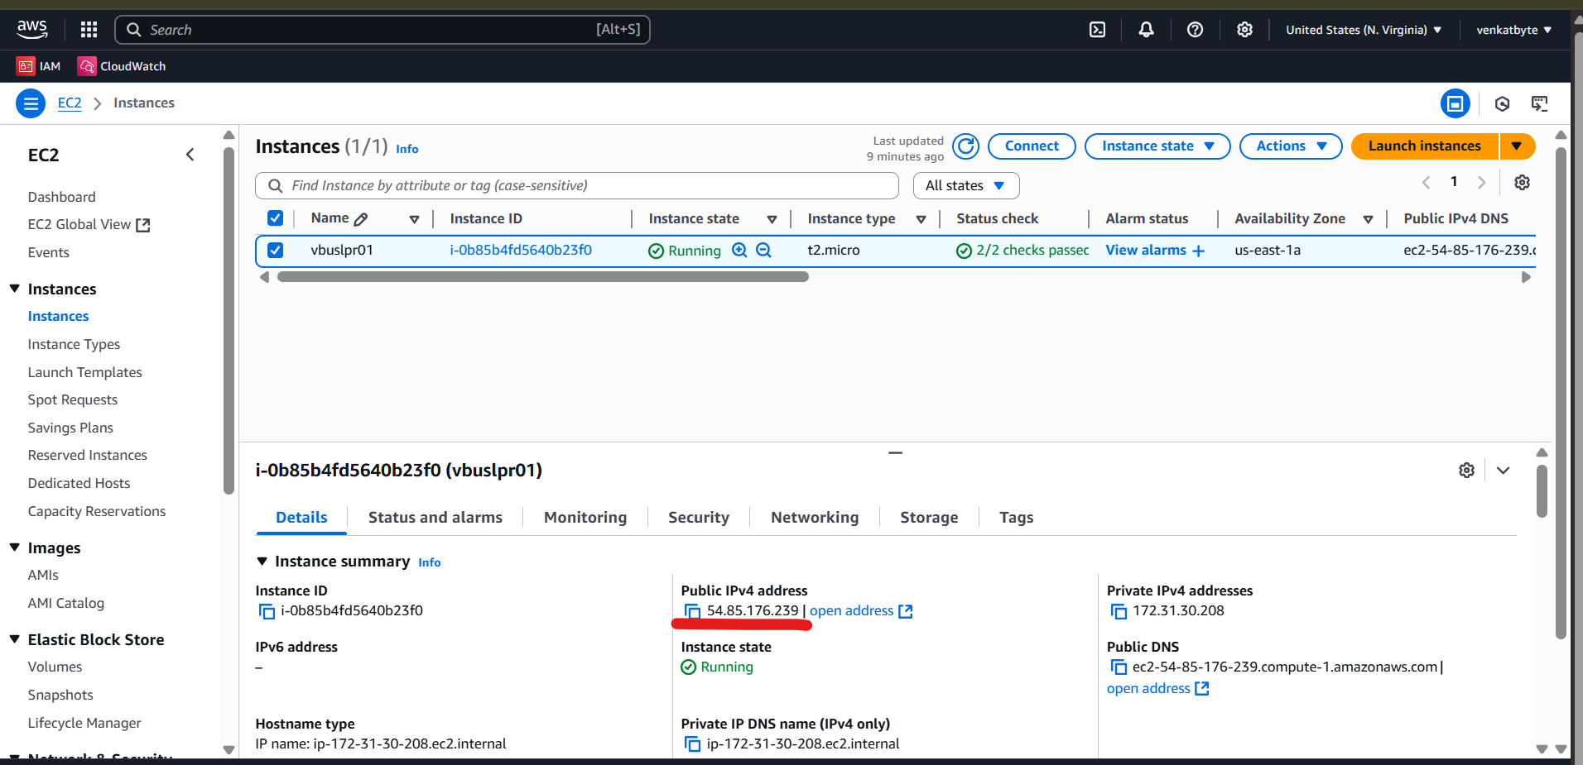

1. Open the Command prompt (CMD) and cd to target folder where you key pair file existed and take ssh like below.

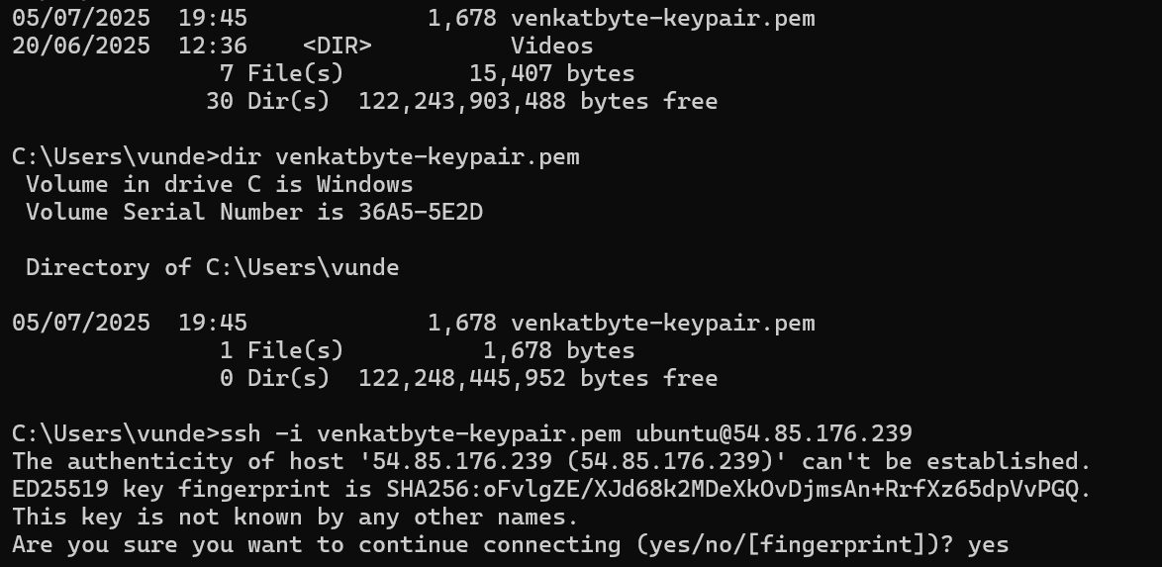

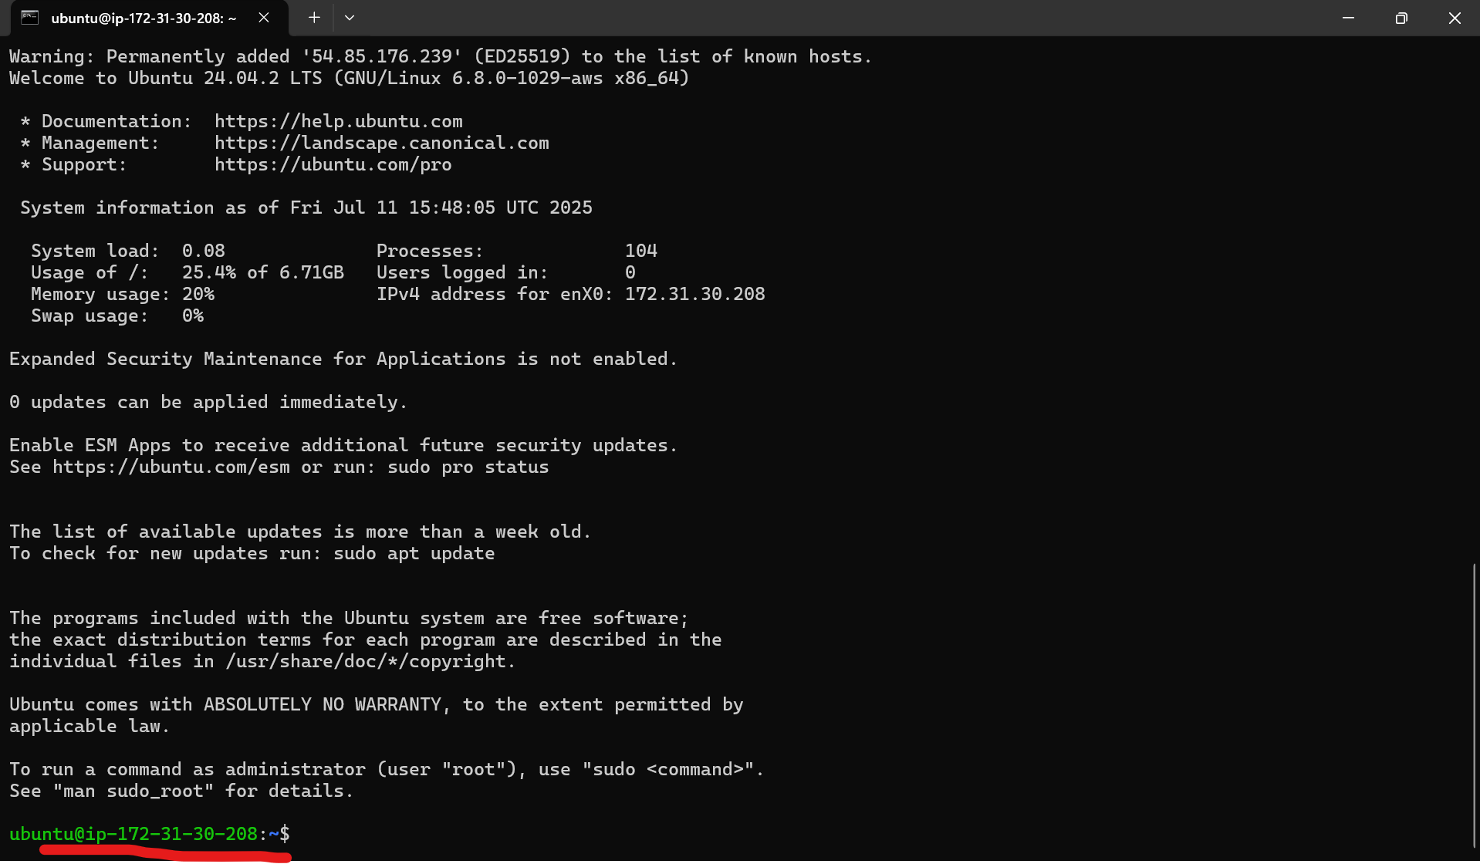

1. You are successfully log into EC2 and you can find the private IP above screenshot and same IP in AWS EC2 instance console.
2. Follow below VENKATBYTE Github link to download and install AWSCLI.

<https://raw.githubusercontent.com/venkatbyte/aws-ami-store-s3/refs/heads/main/Install-aws-ubuntu.docx>

1. Once you followed above link to install AWS CLI, you will run aws –version to validate.



1. Once AWS CLI installed, you need to test your EC2 has access to your AMIs, EBS and S3 Bucket. To test the access, upload the some file or image in S3 bucket and try to retrieve from EC2.

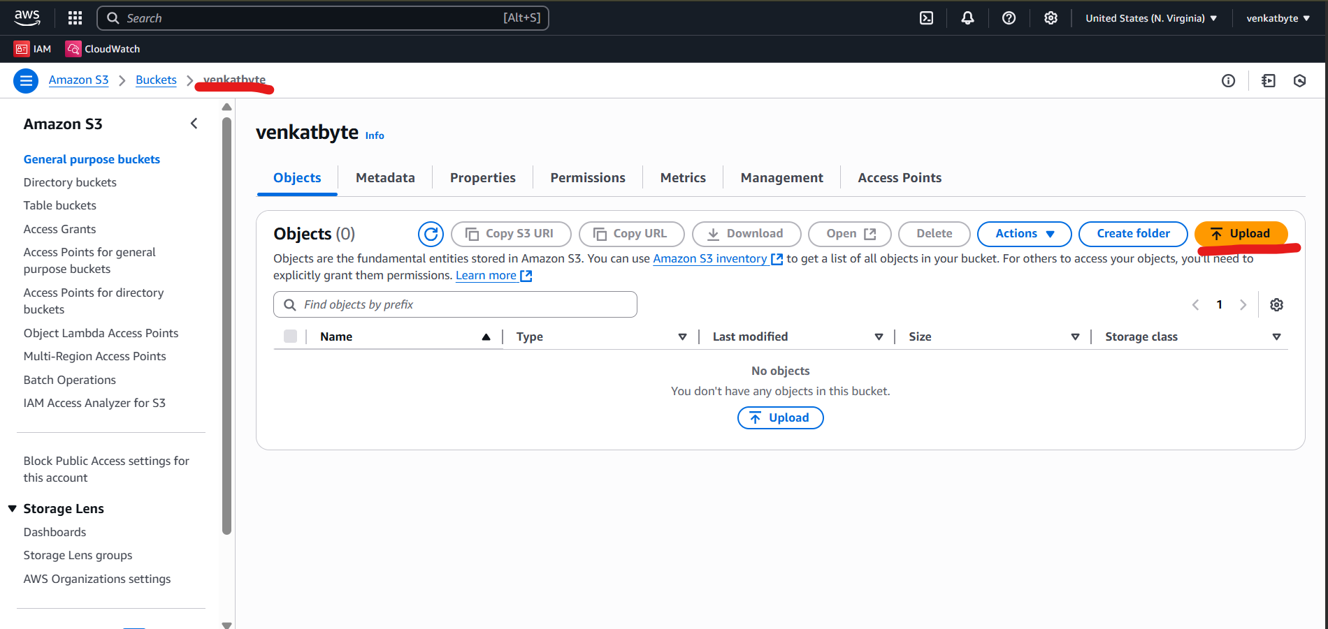

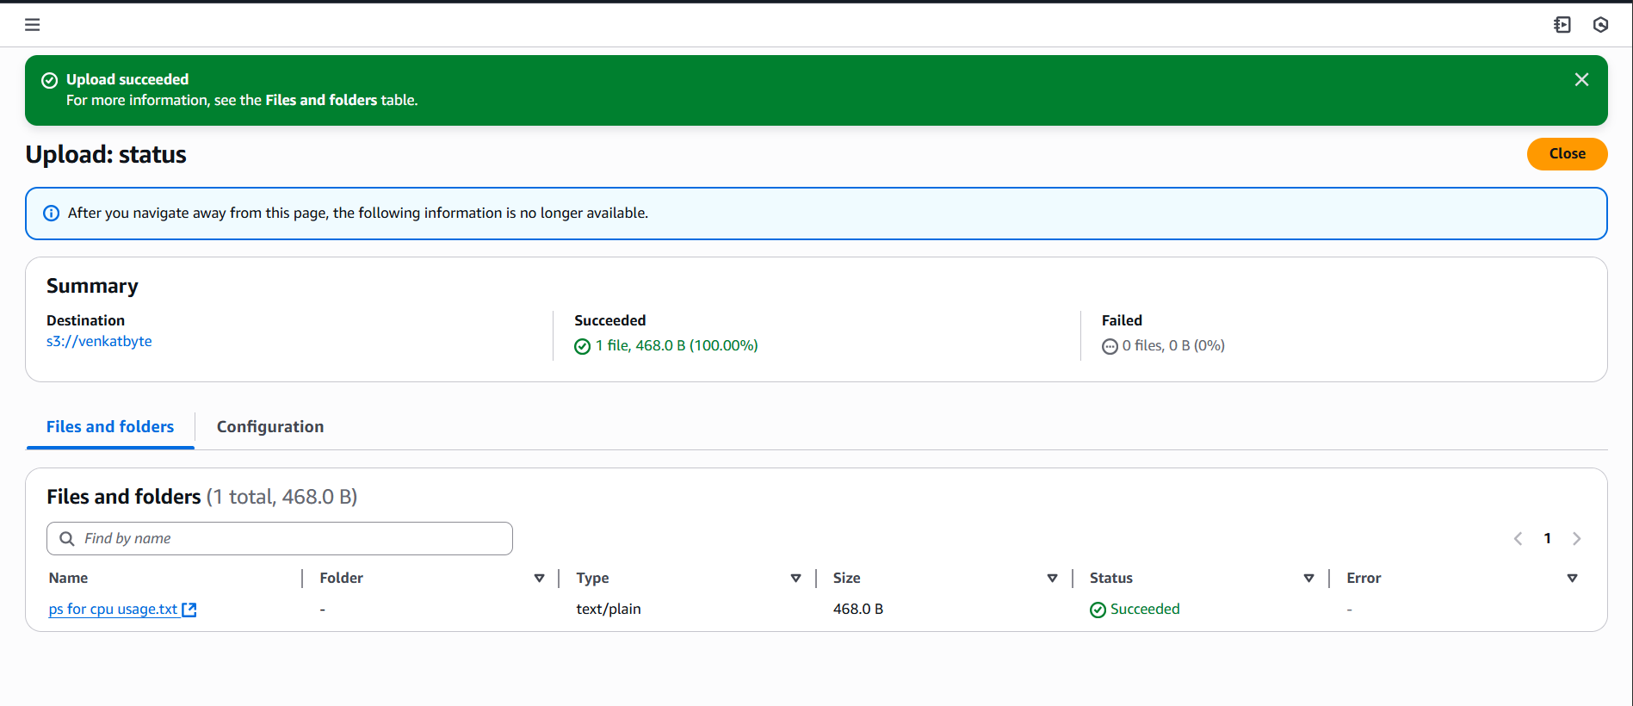

1. Once you uploaded some test file or image into bucket, run the below command to see.

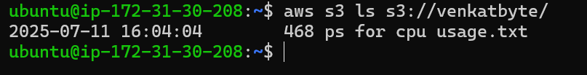

1. If you the file, it means your EC2 instance have right access to S3 and other services.
2. Next step is to create shell script file which is to take image of AMI and upload into to S3 once it is available, until that the script keep checks the status of AMI image.

Copy the script from VENKATBYTE GitHub link.

<https://raw.githubusercontent.com/venkatbyte/aws-ami-store-s3/refs/heads/main/ec2_backup.sh>

In the script, you need to modify EC2 instance ID which you want to take image of AMI. In this example, I am using same EC2 instance ID, in your case, you can use another EC2 instance Id or same which you want to take Image or backup of EC2.

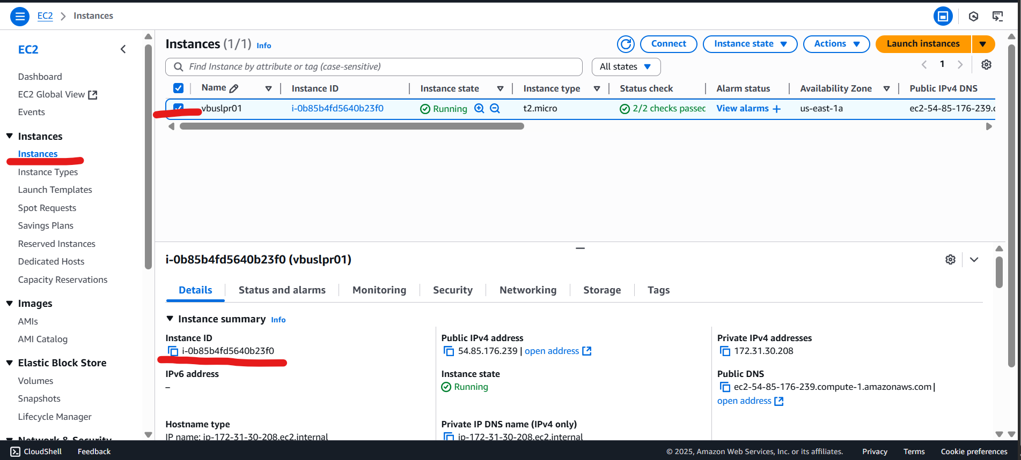

Simple update your Instance ID and S3 bucket name in your script like below.

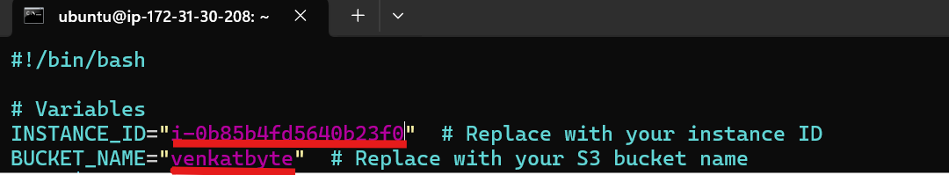

1. Create file, change permissions to executable and update in cron schedule as below.

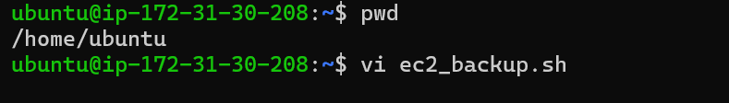

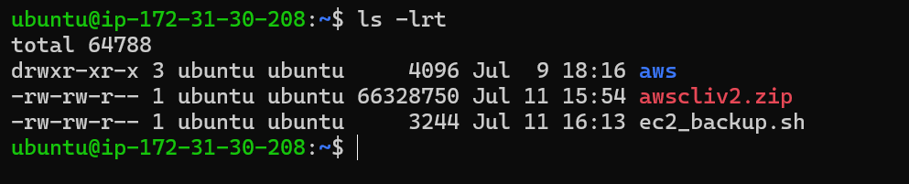

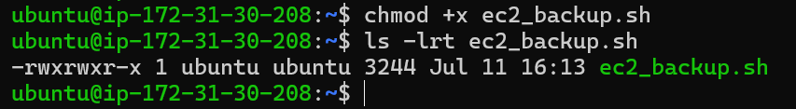

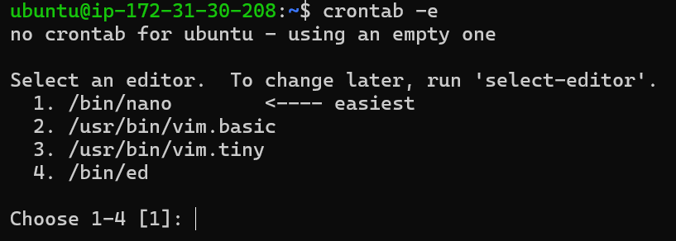

Select option 2 and update below line to the file to auto run at everyday 5 PM local time.

0 17 * * * /home/ubuntu/ec2_backup.sh

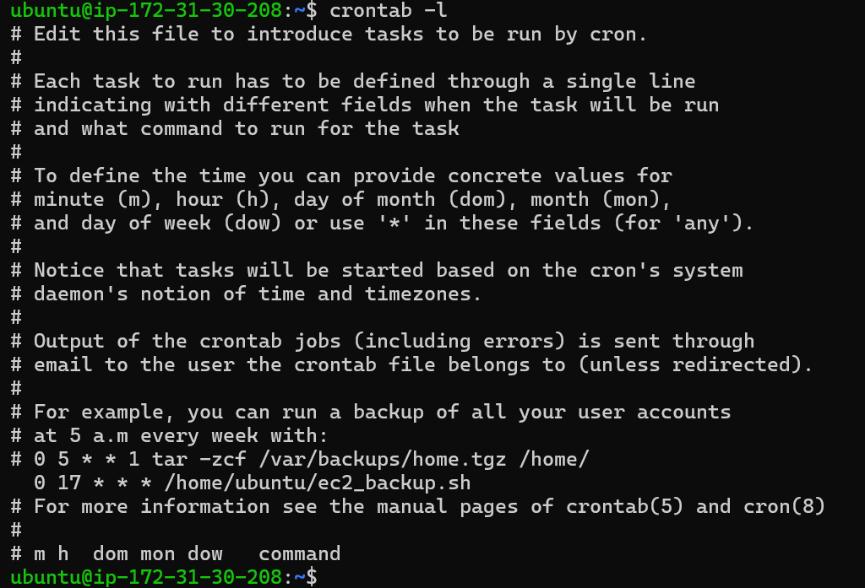

1. In order to test AMI image creation and upload into S3, execute the script manually and verify AMIs and files in your bucket as below.

Before Script run:

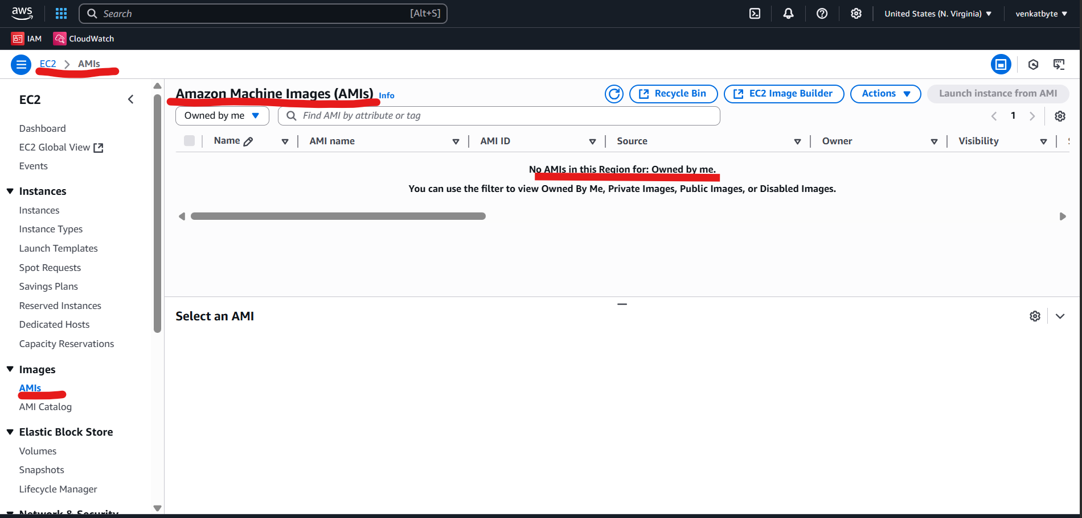

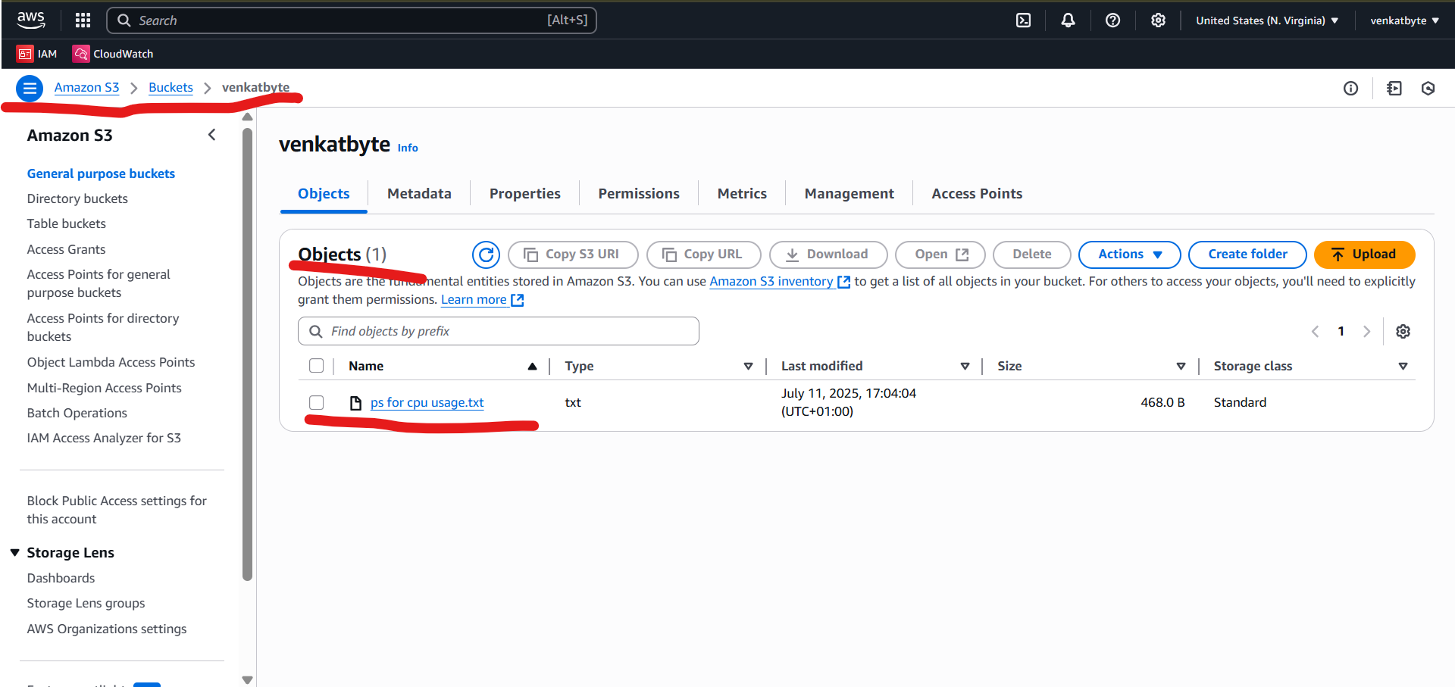

1. Run the script to test AMI creation and upload into S3.



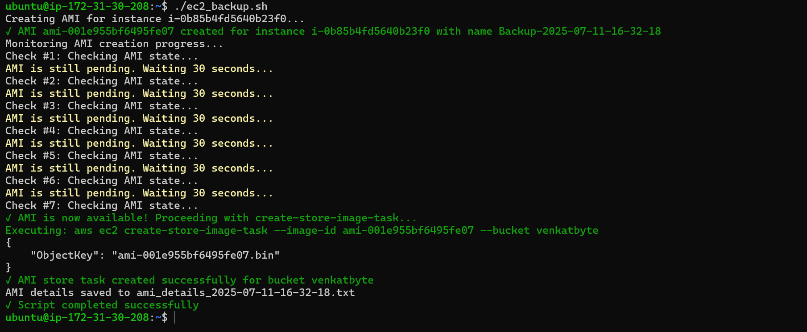

You have successfully created AMI and upload to into S3. Let’s go and see in S3.

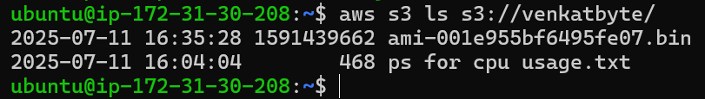

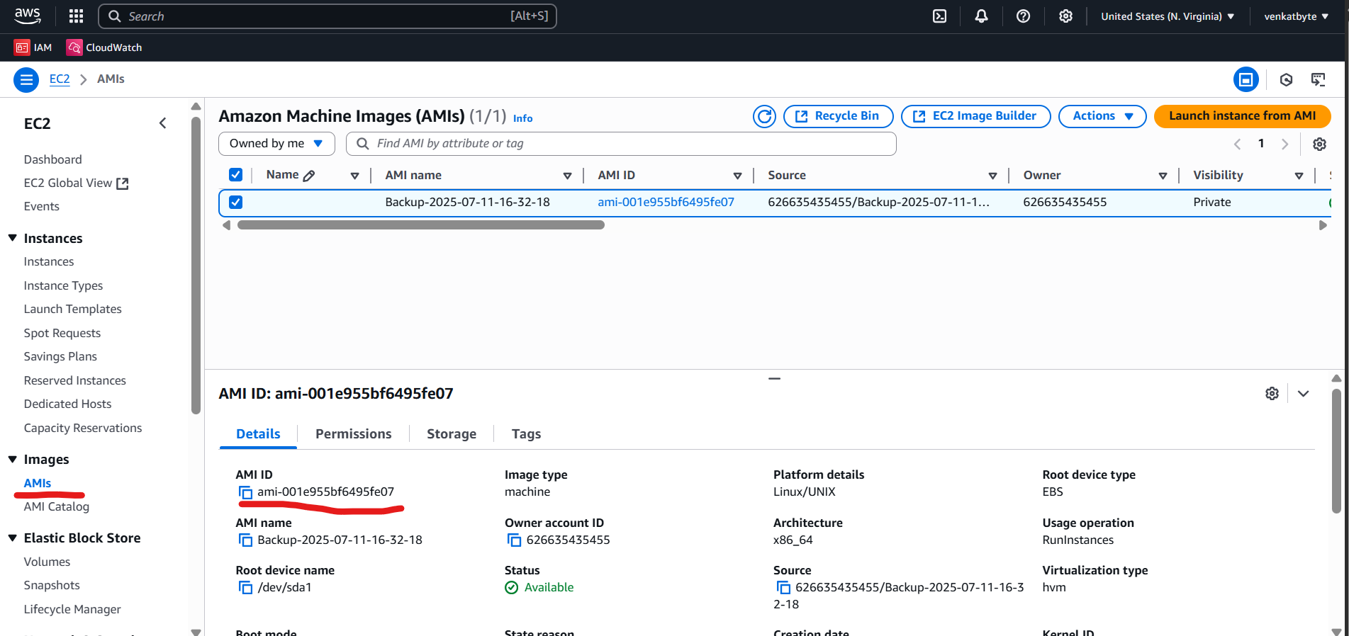

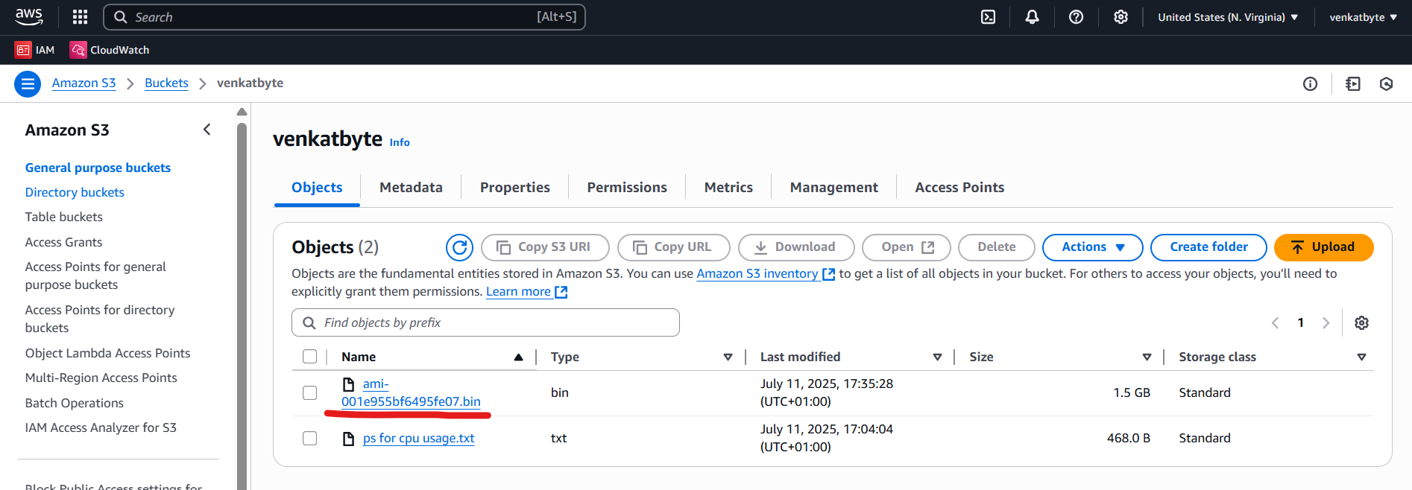

Finally, do not forget to delete the resources which you created as part of the this real time use case to avoid unnecessary cost.